PROJECT MANAGEMENT PLAN · VERSION 3.0
Smart Parking Platform
Real-time parking discovery, reservation, and payment for drivers and operators
Prepared by Anas Altaf, CTO — WE ARE $oftware Corp.
CIS 4374 / TLIM 3355 · Dr. Otto Dobretsberger · Fall 2026
Version 3.0 · December 11, 2026

Project at a glance
Dec 8  Go-live date | $908K  Total budget | 18  Team members | 53  Backlog items

12  Pilot facilities at launch | 14  Stakeholder groups | 16  Risks tracked | Delivered  Project status
CONTENTS

Table of Contents

Document revision history
Version | Date | Changes
1.0 | Sep 10, 2026 | Competitive research, vision and scope, draft SRS (17 use cases).
1.1 | Sep 17, 2026 | Work breakdown structure and project schedule (Gantt chart).
1.2 | Oct 1, 2026 | Product backlog (49 items) and Sprint 1 plan.
2.0 | Oct 16, 2026 | Risk management, communication plan, roles and resources, cost plan, and RACI matrix added. SRS restructured (v1.1); WBS, schedule, backlog, user stories, and sprints updated after Sprint 1.
2.1 | Nov 5, 2026 | Stakeholder analysis with power–interest grid, project charter, and team charter added (Sections 12–14).
3.0 | Dec 11, 2026 | Project closure report added (Section 15, internal).
Table 1. Revision history of this project management plan.
SECTION 1

Research: Competitive Landscape Analysis
Before defining the Smart Parking Platform in detail, WE ARE $oftware Corp. conducted a review of existing parking solutions currently in use across major U.S. markets. This analysis identifies what already exists, where those platforms fall short, and how the Smart Parking Platform can differentiate itself. The review focused on the four platforms most commonly cited as market leaders: SpotHero, ParkWhiz, ParkMobile, and PayByPhone.

1.1 Existing solutions overview
Platform | Core focus | Strengths | Weaknesses / gaps
SpotHero | Pre-booked garage & lot reservations | Large network of garages across North America; dynamic pricing typically well below drive-up rates; strong presence at event venues and airports. | Inventory limited to commercial garages and lots — no street parking or residential spots; limited real-time occupancy granularity once a facility nears capacity.
ParkWhiz | Pre-booked garage & lot reservations, event/airport focus | Guaranteed spot reservations with mobile entry that skips lines; strong event-day and airport parking coverage; data/API integrations for facility owners. | Similar coverage gaps as SpotHero for street parking; pricing can rise sharply during high-demand events, with fewer alternatives shown to the driver.
ParkMobile | Pay-by-phone metered and municipal lot parking | Largest footprint by number of zones/spaces in the U.S.; simple pay-per-session model; strong municipal partnerships for on-street parking. | Charges a per-transaction convenience fee; weaker support for advance reservations in commercial garages; session/GPS syncing issues reported by users when ending a session early.
PayByPhone | Municipal meter and pay-per-session parking | Widely adopted as the official meter partner in many cities; straightforward session-based payment flow. | Coverage depends entirely on which city has adopted it as the official provider; minimal reservation or navigation features compared to garage-focused apps.
Table 2. Summary of leading parking platforms currently in the market.

1.2 Key gaps identified
- Fragmentation: drivers currently need multiple apps to cover both on-street metered parking and off-street garage reservations — no single platform unifies both experiences well.
- Limited real-time granularity: several platforms show a facility as "available" without reflecting live occupancy changes as spaces fill up throughout the day.
- Thin operator tooling: reservation platforms are optimized for the driver-facing experience, while operator-side occupancy reporting, dynamic pricing controls, and analytics are comparatively basic.
- Fee transparency: convenience fees and surge pricing are frequently cited as a source of user frustration, with the total charged at checkout differing from the price shown during search.

1.3 Differentiation opportunities
The Smart Parking Platform will differentiate itself by unifying real-time garage reservations and navigation within a single application, giving parking operators a genuinely robust administrative dashboard (occupancy analytics, dynamic pricing, and reporting) rather than a bolt-on afterthought, and committing to upfront, all-inclusive pricing at the point of search rather than at checkout. Because WE ARE $oftware Corp. operates under a theoretically unlimited development budget, the platform can also invest more heavily in the reliability of real-time availability data and third-party mapping integration than competitors who are more cost-constrained.
SECTION 2

Vision and Scope

2.1 Project origin
WE ARE $oftware Corp. was engaged after a coalition of mid-sized city transportation departments issued a joint request for proposals (RFP) seeking a unified platform to reduce downtown congestion caused by drivers circling in search of parking. Existing point solutions in the market addressed only pieces of the problem — payment, reservations, or navigation individually — and no vendor offered an end-to-end platform covering both the driver experience and operator-side management tools. WE ARE $oftware Corp. was selected based on its proposed unified architecture and its ability to commit development resources without the budget constraints that limited competing bids.

2.2 Company introduction
WE ARE $oftware Corp. is a software development studio positioned to take on ambitious, resource-intensive builds without the typical constraints of budget. The company's structure centers on cross-functional delivery teams — Mobile, Web, Backend/API, Mapping & Location Services, Payment Integration, and Quality Assurance & Testing — organized to move in parallel on a single coordinated release plan rather than in strict sequence. This structure is intended to compress the delivery timeline for the Smart Parking Platform despite the fixed semester-length schedule.

2.3 Project overview
The Smart Parking Platform is a web and mobile system that allows drivers to locate, reserve, and pay for parking spaces in real time, while giving parking facility operators the tools to monitor occupancy, adjust pricing, and improve utilization of their assets. The platform addresses a well-documented urban problem: drivers spend significant time searching for available parking, which contributes to congestion, driver frustration, and lost productivity, while operators lack modern tools to manage and optimize their existing capacity.

2.4 Objectives and success criteria
The project kicked off on August 31, 2026, when the sponsor approved the project charter and confirmed the following objectives and success criteria.
- Deliver on time: launch the driver apps, operator dashboard, and city data portal in production by December 8, 2026.
- Prove operator value: onboard at least 10 pilot facilities before go-live.
- Meet quality targets: meet the performance, availability, and accessibility targets in the SRS (NFR-01 to NFR-12).
- Control cost: complete the project within the total budget of $908,292 (Section 10).

2.5 In scope
- Driver-facing web and mobile applications covering registration, search, reservation, payment, and navigation.
- Operator-facing administrative dashboard covering facility management, pricing, and occupancy analytics.
- Read-only, anonymized occupancy data access for city transportation departments.
- Integration with third-party mapping/navigation services and third-party payment processors.
- Notification and alerting system for reservation and account activity.

2.6 Out of scope (initial release)
- Hardware installation at parking facilities (e.g., physical gate sensors or license-plate cameras) — assumed to be handled by each facility's existing infrastructure or a future phase.
- Direct integration with municipal on-street meter systems — the initial release focuses on off-street garage and lot facilities.
- Could-have backlog items (Section 6), which are deferred to a post-launch release.
SECTION 3

Software Requirements Specification (SRS)
Project | Smart Parking Platform
Document | Software Requirements Specification
Version | 1.1
Date | October 16, 2026
Prepared by | Elena Ortiz, Business Analyst; Anas Altaf, CTO
Approved by | Marcus Bell, Product Owner
History | 1.0 (Sep 10, 2026) initial draft and use cases; 1.1 (Oct 16, 2026) restructured with introduction, overall description, requirements, constraints, and traceability

3.1 Introduction
Purpose
This SRS defines the functional and non-functional requirements of the Smart Parking Platform. It is the agreed reference for the delivery teams, the basis for test planning in WBS 8.0, and the source from which product backlog items (Section 6) are derived.
Scope
The platform consists of native iOS and Android apps and a web app for drivers, a web dashboard for parking operators, an administration console, and a read-only data portal for city transportation departments, supported by a cloud backend that integrates third-party mapping and payment services. Scope boundaries are listed in Sections 2.5 and 2.6.
Definitions and acronyms
Term | Definition
SRS | Software Requirements Specification; this section of the plan.
Facility | A parking garage or surface lot listed on the platform.
Hold | A temporary 10-minute reservation of a space while the driver completes payment.
Operator | A business or staff member that manages one or more facilities.
MoSCoW | Prioritization scheme: Must have, Should have, Could have, Won't have (this release).
RBAC / MFA | Role-based access control / multi-factor authentication.
PCI DSS | Payment Card Industry Data Security Standard.
Tokenization | Replacing card data with a processor-issued token so card numbers never reach platform servers.
WCAG 2.1 AA | Web Content Accessibility Guidelines, version 2.1, conformance level AA.
P95 | 95th percentile; 95% of requests complete within the stated time.
Table 3. SRS definitions and acronyms.
References
- Section 1 (competitive analysis) and Section 2 (vision and scope) of this plan.
- Project charter, approved at kickoff on August 31, 2026.
- PCI DSS v4.0; WCAG 2.1; IEEE 830 recommended practice for software requirements specifications.
Document overview
Section 3.2 describes the product and its users; Sections 3.3 and 3.4 specify functional and non-functional requirements; Section 3.5 details use cases and exception flows; Sections 3.6 and 3.7 list constraints, assumptions, and dependencies.

3.2 Overall description
Product perspective
The Smart Parking Platform is a new, self-contained system. It depends on three external services: a mapping and navigation provider, a PCI DSS-compliant payment processor, and facility occupancy feeds (sensors where available). It replaces the fragmented mix of separate reservation, payment, and navigation apps described in Section 1.
Product functions
- Account registration, authentication, and role-based access.
- Location-based search with live or estimated availability on an interactive map.
- Reservation with a 10-minute payment hold, tokenized payment, cancellation, and receipts.
- Turn-by-turn navigation hand-off and notifications.
- Operator facility, pricing, and availability management with occupancy and revenue reporting.
- Administration, audit logging, finance reconciliation, and anonymized city data access.
User classes and characteristics
User class | Description | Frequency | Expertise | Primary needs
Driver | Individuals who search for, reserve, and pay for parking. | Daily to weekly | Low to moderate | Fast search, live availability, upfront price, easy payment.
Parking Operator | Facility managers and on-site staff. | Daily | Moderate | Occupancy visibility, pricing control, reports.
System Administrator | Platform staff managing accounts and integrations. | Weekly | High | Account control, audit trail, integration health.
Finance / Billing | Staff reconciling payments and refunds. | Weekly | Moderate | Accurate ledgers, refund tools, exportable records.
City Transportation Dept. | Planners using aggregated utilization data. | Monthly | Moderate | Anonymized, district-level occupancy trends.
Table 4. User classes and characteristics.
Operating environment
Native apps run on iOS and Android (current and previous major versions). Web interfaces run on current Chrome, Safari, Edge, and Firefox. The backend is hosted on a commercial cloud platform in U.S. regions, with separate development, test, and production environments.

3.3 Functional requirements
Each functional requirement is prioritized with MoSCoW and traced to the use case it satisfies and the backlog items that implement it. FR-21 and FR-22 were added in this version in response to risks T-02 and T-01 (Section 7).
ID | Requirement | Priority | Use case | Backlog
FR-01 | Drivers can register with email or phone and verify the account before first reservation. | Must | UC-01 | LG-01, BE-02
FR-02 | The system authenticates users and routes them by role (Driver, Operator, Admin, City). | Must | UC-02, UC-11 | LG-02, LG-05
FR-03 | Users can reset a forgotten password through a time-limited emailed link. | Must | UC-02 | LG-03
FR-04 | Users can enable multi-factor authentication; MFA is mandatory for Operator and Admin roles. | Should | UC-02 | LG-04
FR-05 | Drivers can search facilities by current location or destination within a configurable radius. | Must | UC-03 | BE-03, UI-01
FR-06 | Available facilities display on an interactive map with live space counts. | Must | UC-04 | BE-04, UI-02, UI-03
FR-07 | Drivers can reserve a space for a time window; the space is held for 10 minutes pending payment. | Must | UC-05 | BE-05, BE-06, UI-04
FR-08 | Payments are processed through a tokenized third-party gateway; the price shown at search is the total charged. | Must | UC-06 | BE-08, UI-05
FR-09 | Drivers can cancel reservations; refunds follow each operator's cancellation policy. | Must | UC-07, UC-17 | BE-07
FR-10 | Drivers can view reservation history and download receipts. | Must | UC-08 | BE-09, UI-07, UI-08
FR-11 | The system sends push, email, or SMS notifications for reservation and payment events. | Should | UC-09 | BE-10, UI-09
FR-12 | Drivers can hand off to a mapping provider for turn-by-turn navigation. | Must | UC-10 | BE-11
FR-13 | Operators can create, edit, and deactivate facility listings; addresses are geocoded. | Must | UC-14 | BE-13, UI-12
FR-14 | Operator changes to pricing or availability are visible to drivers within 60 seconds. | Must | UC-12 | BE-12, UI-13, UI-14
FR-15 | Operators can run occupancy and revenue reports and export them to CSV or PDF. | Must | UC-13 | RP-01, RP-02, RP-06
FR-16 | Admins can manage accounts; every admin action is written to an audit log. | Must | UC-15 | BE-14, UI-16
FR-17 | Admins can configure third-party integrations and rotate API credentials. | Should | UC-16 | BE-08, BE-11
FR-18 | Finance staff can reconcile transactions and issue manual refunds. | Must | UC-17 | BE-07
FR-19 | City transportation departments can access anonymized, district-level occupancy data. | Should | UC-18 | RP-11, UI-17
FR-20 | Drivers can view monthly spend summaries and export parking history. | Could | UC-08 | RP-08, RP-09
FR-21 | For facilities without sensors, availability is estimated from reservations and operator updates and labeled "estimated" to drivers. | Must | UC-04 | BE-18
FR-22 | If the primary mapping provider is unavailable, search and navigation fall back to a secondary provider and cached facility data. | Should | UC-03, UC-10 | BE-17
Table 5. Functional requirements with traceability to use cases and backlog items.

3.4 Non-functional requirements
ID | Category | Requirement
NFR-01 | Performance | Search results return within 2 seconds at the 95th percentile.
NFR-02 | Data freshness | Space availability shown to drivers is no more than 30 seconds old.
NFR-03 | Availability | 99.9% monthly uptime, excluding announced maintenance windows.
NFR-04 | Scalability | Supports 10,000 concurrent users and 500 facilities at launch without degradation.
NFR-05 | Security | All traffic uses TLS 1.2 or higher; personal data is encrypted at rest with AES-256.
NFR-06 | Payment compliance | Card data is never stored on platform servers; payments are tokenized through a PCI DSS-compliant processor.
NFR-07 | Privacy | Location is collected only with user consent; personal data follows a documented retention and deletion policy aligned with applicable state privacy law.
NFR-08 | Regulatory | Pricing display and fee disclosure meet applicable city ordinances; city data sharing contains no personal information.
NFR-09 | Accessibility | Web and mobile interfaces meet WCAG 2.1 Level AA.
NFR-10 | Usability | A returning driver can complete a reservation in under 60 seconds from search.
NFR-11 | Auditability | Admin and payment actions are logged and retained for at least one year.
NFR-12 | Compatibility | iOS and Android (current and previous major versions); current Chrome, Safari, Edge, and Firefox.
Table 6. Non-functional requirements.

3.5 Use cases
The use case inventory covers all five user classes. UC-18 was added after stakeholder review identified city transportation departments as a user class without a use case.
ID | Use case | Actor | Trigger / description | Main flow (summary) | Postcondition
UC-01 | Register Account | Driver | New user opens the app and elects to create an account. | 1) User provides name, email, phone, password. 2) System validates input and checks for duplicates. 3) System creates account and sends confirmation. | Driver has an active account and can log in.
UC-02 | Log In / Authenticate | Driver / Operator / Admin | Registered user opens the app or web portal. | 1) User enters credentials. 2) System validates credentials against stored records. 3) System grants role-based access. | User is authenticated and routed to the appropriate dashboard.
UC-03 | Search for Available Parking | Driver | Driver enters a destination or enables location services. | 1) System retrieves driver's location or entered address. 2) System queries real-time availability for nearby garages. 3) Results are ranked by distance, price, and availability. | Driver receives a list of nearby available parking options.
UC-04 | View Parking Locations on Interactive Map | Driver | Driver opens the map view from search results. | 1) System renders available garages as map pins. 2) Driver taps a pin to view pricing, distance, and availability. 3) Map updates in real time as occupancy changes. | Driver has a visual, real-time view of nearby parking options.
UC-05 | Reserve a Parking Space | Driver | Driver selects a specific garage and time window. | 1) Driver selects entry/exit time. 2) System checks space availability for that window. 3) System places a 10-minute hold on the space pending payment. | A reservation is created and held pending payment confirmation.
UC-06 | Make Digital Payment for Reservation | Driver | Driver confirms a reservation and proceeds to checkout. | 1) Driver selects a stored or new payment method. 2) System sends a tokenized payment request to the processor. 3) System confirms payment and finalizes the reservation. | Reservation is confirmed and payment is recorded.
UC-07 | Cancel a Reservation | Driver | Driver opens an active reservation and selects cancel. | 1) System checks the cancellation window against operator policy. 2) System releases the held space. 3) System processes a refund if applicable. | Reservation is cancelled and the space is returned to available inventory.
UC-08 | View Reservation History and Receipts | Driver | Driver navigates to the reservation history screen. | 1) System retrieves past and current reservations tied to the account. 2) Driver selects a reservation. 3) System displays or exports a digital receipt. | Driver can view or download a record of past parking transactions.
UC-09 | Receive Notifications and Alerts | Driver | A reservation-related or system event occurs (e.g., reservation expiring, payment issue). | 1) System detects a triggering event. 2) System generates a notification. 3) Notification is pushed to the driver's device or email. | Driver is informed of time-sensitive account or reservation activity.
UC-10 | Navigate to Reserved Parking Garage | Driver | Driver selects "Navigate" from an active reservation. | 1) System passes garage coordinates to an external mapping/navigation service. 2) External service returns turn-by-turn directions. 3) App displays estimated arrival time. | Driver receives directions to the reserved garage entrance.
UC-11 | Log In to Operator Dashboard | Parking Operator | Operator opens the web-based management portal. | 1) Operator enters credentials. 2) System validates operator role and facility assignment. 3) System loads the operator dashboard. | Operator has access to facility-specific management tools.
UC-12 | Update Space Availability and Pricing | Parking Operator | Operator needs to adjust rates or block off spaces (e.g., maintenance, private event). | 1) Operator selects a facility. 2) Operator edits available space count or pricing rules. 3) System propagates changes to real-time availability shown to drivers. | Updated availability and pricing are reflected across the platform.
UC-13 | View Occupancy Reports and Analytics | Parking Operator | Operator requests a usage or revenue report. | 1) Operator selects a facility and date range. 2) System aggregates reservation and occupancy data. 3) System renders charts and summary metrics. | Operator receives actionable insight into utilization and revenue.
UC-14 | Manage Facility Listing | Parking Operator | Operator needs to add, edit, or deactivate a garage listing. | 1) Operator submits facility details (address, capacity, hours, amenities). 2) System validates and geocodes the address. 3) Listing becomes searchable to drivers upon approval. | Facility listing is created, updated, or deactivated on the platform.
UC-15 | Manage User Accounts | System Administrator | Admin needs to review, suspend, or modify a user or operator account. | 1) Admin searches for an account. 2) Admin reviews account activity and status. 3) Admin applies an action (edit, suspend, reinstate). | Account status is updated and the action is logged for audit purposes.
UC-16 | Configure Third-Party Integrations | System Administrator | Admin needs to add or update an external API (mapping, payment processor). | 1) Admin selects the integration to configure. 2) Admin enters or rotates API credentials. 3) System validates the connection. | Integration is active and available to the rest of the platform.
UC-17 | Process Refunds and Reconcile Transactions | Finance/Billing Personnel | A cancellation, dispute, or billing discrepancy requires manual review. | 1) Finance staff pulls the transaction record. 2) Staff verifies the refund or adjustment against policy. 3) System processes the refund through the payment processor and updates the ledger. | Transaction is reconciled and any refund is issued to the driver.
UC-18 | Access Anonymized Occupancy Data | City Transportation Department | City planner requests district-level parking utilization data. | 1) City user logs in to a read-only portal. 2) Selects district and date range. 3) System returns aggregated, anonymized occupancy data with export. | City receives utilization data with no personal information.
Table 7. Use case inventory (18 use cases).
Alternate and exception flows
Use case | Condition | System response
UC-02 | Five consecutive failed login attempts | Account is locked for 15 minutes; user is offered a password reset link.
UC-03 | Location services denied | System prompts for a manual address or destination and continues the search.
UC-03 | No availability within search radius | System suggests expanding the radius and lists the nearest facilities with open spaces.
UC-05 | Space is taken while the driver is selecting a time | Hold is not created; system presents the next-best options at the same facility and nearby.
UC-05 | 10-minute hold expires without payment | Hold is released automatically and the space returns to inventory; driver is notified.
UC-06 | Payment declined | Reservation stays on hold for the remaining hold time; driver may retry or choose another method.
UC-06 | Payment gateway times out | No charge is confirmed; the retry uses the same idempotency key so the driver is never charged twice.
UC-07 | Cancellation outside the free-cancellation window | Partial or no refund amount is displayed before the driver confirms the cancellation.
UC-10 | Navigation service unavailable | App shows the facility address with a copy-to-maps fallback.
UC-12 | Price changes while a driver is mid-checkout | The driver is charged the price shown when the hold was created.
Table 8. Alternate and exception flows for key use cases.

3.6 Constraints
Type | Constraint
Schedule | Fixed semester timeline: production go-live by December 8, 2026 and project close by December 11, 2026.
Third-party dependency | Mapping, navigation, and payment capabilities depend on external providers' APIs, pricing, and availability.
Regulatory | Must comply with PCI DSS for payments, applicable state privacy law for personal and location data, and city parking ordinances.
Hardware | No hardware is installed at facilities; occupancy data comes from existing sensors, operator updates, or reservation-based estimates.
Platforms | Native iOS and Android apps plus a responsive web app; no desktop client.
Budget | The development budget is theoretically unlimited, but all spending is controlled against the cost baseline in Section 10.
Table 9. Design and project constraints.

3.7 Assumptions and dependencies
- Participating facilities provide occupancy data through sensors or operator updates.
- A PCI DSS-compliant payment processor and a commercial mapping provider are contracted before Sprint 3.
- City transportation departments agree to the anonymization standard before data sharing begins.
- Drivers use a smartphone or browser meeting the compatibility targets in NFR-12.
SECTION 4

Work Breakdown Structure
The work breakdown structure decomposes the Smart Parking Platform into nine top-level work packages aligned with the development teams and lifecycle phases. Package 1.0 was later expanded with 1.4 Resource & Cost Management and 1.5 Project Closure & Handover; 1.2 covers communication management, and 4.2 includes operator reporting and the city data portal.

4.1 WBS diagram (Level 0–1)
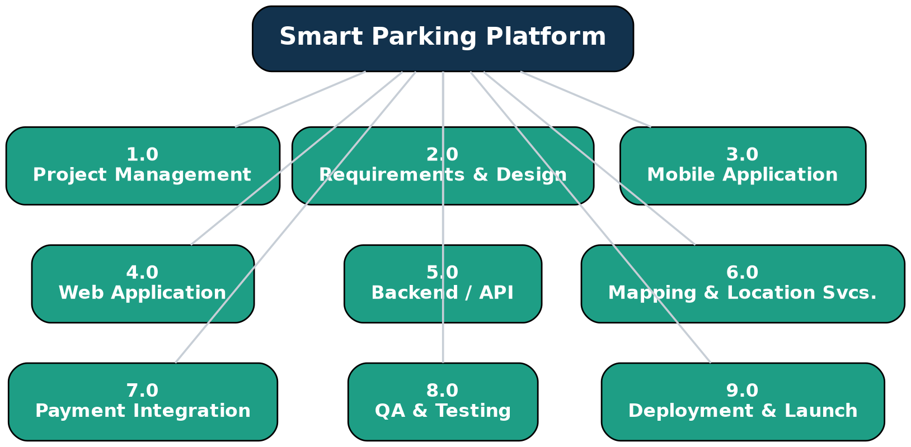
Figure 1. Top-level work breakdown structure for the Smart Parking Platform.

4.2 WBS decomposition (Level 2)
WBS ID | Element | Description
1.1 | Planning & Scheduling | Develop the project schedule, milestones, and resource allocation plan for the semester timeline.
1.2 | Stakeholder & Communication Mgmt | Execute the communication plan (Section 8): meeting cadence, status reporting, and stakeholder engagement.
1.3 | Risk Management | Maintain the risk register (Section 7), review weekly, and manage contingency reserve.
1.4 | Resource & Cost Management | Staff the project (Section 9), track allocation, and control cost against the baseline (Section 10).
1.5 | Project Closure & Handover | Hand over to operations, close contracts, archive documentation, and complete the closure report (Section 15).
2.1 | Requirements Elicitation (SRS) | Gather and document functional and non-functional requirements from stakeholder groups.
2.2 | UX / UI Design | Design wireframes and interaction flows for the driver and operator experiences.
2.3 | System Architecture | Define the overall technical architecture and how subsystems integrate.
3.1 | iOS App Development | Build the driver-facing iOS application.
3.2 | Android App Development | Build the driver-facing Android application.
3.3 | Mobile QA | Test mobile applications across devices and OS versions.
4.1 | Driver Web Frontend | Build the driver-facing web application.
4.2 | Operator Dashboard & Reporting | Build the operator dashboard, operator and driver reports, and the city data portal.
4.3 | Web QA | Test web applications across browsers and screen sizes.
5.1 | Core API Development | Build the backend services and APIs that power the platform.
5.2 | Database Design | Design and implement the data model for reservations, users, and facilities.
5.3 | Authentication & Authorization | Implement secure login and role-based access control.
6.1 | Real-Time Availability Engine | Track and update live parking space availability.
6.2 | Navigation Integration | Integrate with third-party mapping/navigation services.
6.3 | Geolocation Services | Determine driver location and proximity to available facilities.
7.1 | Payment Gateway Integration | Integrate with third-party payment processors for digital payments.
7.2 | Billing & Receipts | Generate and deliver digital receipts for reservations.
7.3 | Refund Processing | Handle cancellations and process refunds.
8.1 | Test Planning | Define the overall test strategy and acceptance criteria.
8.2 | Functional Testing | Validate that features work as specified across the platform.
8.3 | Performance & Security Testing | Validate system performance under load and compliance with security requirements.
9.1 | Infrastructure Setup | Provision hosting, environments, and CI/CD pipelines.
9.2 | Production Rollout | Deploy the platform to production and onboard initial parking facilities.
9.3 | Post-Launch Support | Monitor the platform and address issues after launch.
Table 10. Level 2 decomposition of each work package (29 elements).
SECTION 5

Project Schedule
The schedule maps every Level 2 WBS element onto the fixed Fall 2026 timeline (August 31 – December 11, 2026). Development runs in two-week Scrum sprints inside this schedule. The schedule was re-baselined on October 16, 2026 after Sprint 1, and the project closed on December 11, 2026. Go-live was delivered on the planned date of December 8; the only slips were two working days on the MVP milestone, caused by payment certification, and one day on test completion.
Dec 8  Go-live (on plan) | 9 / 9  Milestones reached | 100%  Work packages complete | +2 days  Largest milestone slip

5.1 Milestones
Milestone | Planned | Actual | Definition of done | Status
Project kickoff | Aug 31 | Aug 31 | Charter approved; teams, objectives, and success criteria confirmed. | Met
Requirements sign-off | Sep 25 | Sep 25 | Stakeholder-approved requirements baseline (SRS v1.0). | Met
Architecture approved | Oct 2 | Oct 2 | Architecture and data model approved; development unblocked. | Met
Sprint 1 review | Oct 16 | Oct 16 | Secure account foundation demonstrated to stakeholders. | Met
MVP feature complete | Nov 13 | Nov 17 | All Must-have backlog items done. | Met late
Release scope complete | Nov 27 | Nov 27 | All release-scope Should-have items done. | Met
Testing complete | Dec 2 | Dec 3 | Functional, performance, and security testing signed off. | Met late
Go-live | Dec 8 | Dec 8 | Production rollout; 12 pilot facilities onboarded. | Met
Project closure | Dec 11 | Dec 11 | Handover complete; closure report approved (Section 15). | Met
Table 11. Planned and actual milestone dates (2026) at project close.

5.2 Sprint calendar
Sprint | Dates | Sprint goal | Items | Points | Status
Sprint 0 | Sep 21 – Oct 2 | Design, architecture, and team onboarding | — | — | Done
Sprint 1 | Oct 5 – 16 | Secure account foundation | 9 | 42 committed / 39 done | Done
Sprint 2 | Oct 19 – 30 | Search and live availability | 13 | 69 committed / 64 done | Done
Sprint 3 | Nov 2 – 13 | Book and pay end to end; operator controls (MVP) | 15 | 75 committed / 70 done | Done
Sprint 4 | Nov 16 – 27 | Reporting, city access, and hardening | 11 | 56 committed / 48 done | Done
Release | Nov 30 – Dec 11 | Test sign-off, production rollout, hypercare | — | — | Done
Table 12. Sprint calendar and delivered scope.

5.3 Schedule changes
WBS | Task | Previous dates | New dates | Reason
1.4 | Resource & Cost Management | — | Sep 8 – Dec 11 | New work package for resource and cost control.
3.1 / 3.2 | iOS and Android development | Oct 12 – Nov 13 | Oct 19 – Nov 13 | Aligned with the Sprint 2 start once UX design and the auth API were complete.
4.1 | Driver web frontend | Oct 12 – Nov 13 | Oct 19 – Nov 13 | Aligned with the Sprint 2 start.
4.2 | Operator dashboard & reporting | Oct 26 – Nov 13 | Oct 19 – Nov 27 | Reporting and city portal added to release scope (Sprint 4).
4.3 | Web QA | Nov 9 – Nov 20 | Nov 9 – Nov 25 | Extended to cover Sprint 4 operator features.
5.1 | Core API development | Oct 12 – Nov 6 | Oct 12 – Nov 13 | Absorbs reservation, refund, and receipt APIs planned for Sprint 3.
5.3 | Authentication & authorization | Oct 5 – Oct 16 | Oct 5 – Oct 30 | Audit logging carried over from Sprint 1; MFA added to Sprint 2.
6.2 | Navigation integration | Oct 26 – Nov 6 | Oct 19 – Oct 30 | Pulled forward to support the Sprint 2 search demo.
6.3 | Geolocation services | Oct 12 – Oct 23 | Oct 19 – Oct 30 | Sequenced after database design completed.
7.1 | Payment gateway integration | Oct 19 – Nov 6 | Oct 26 – Nov 13 | Sandbox opens Oct 26; build follows the reservation API contract.
7.3 | Refund processing | Nov 9 – Nov 13 | Nov 2 – Nov 13 | Built alongside billing in Sprint 3.
1.5 | Project closure & handover | — | Dec 7 – Dec 11 | Added for handover, contract closure, and the closure report.
7.1 | Payment gateway integration (actual) | Oct 26 – Nov 13 | Oct 26 – Nov 17 | Payment certification took two extra working days (risk S-02).
8.3 | Performance & security testing (actual) | Nov 23 – Dec 2 | Nov 23 – Dec 3 | Remediation of two penetration-test findings (risk F-03).
Table 13. Schedule changes: re-baseline at the Sprint 1 review (October 16) and actual variances at close.

5.4 Scheduling assumptions
- The go-live date is a hard constraint; scope, not time, is the lever if the schedule slips.
- Project management activities (1.1–1.4) run for the full project duration; closure (1.5) runs in the final week.
- Payment integration (7.1) starts after the reservation API contract is defined, with sandbox access from October 26.
- QA overlaps the final development weeks so testing begins on completed features.
- The Gantt chart is maintained in Microsoft Excel (Smart_Parking_Schedule_and_Cost.xlsx); bars are driven by each task's start and end dates.

5.5 Gantt chart
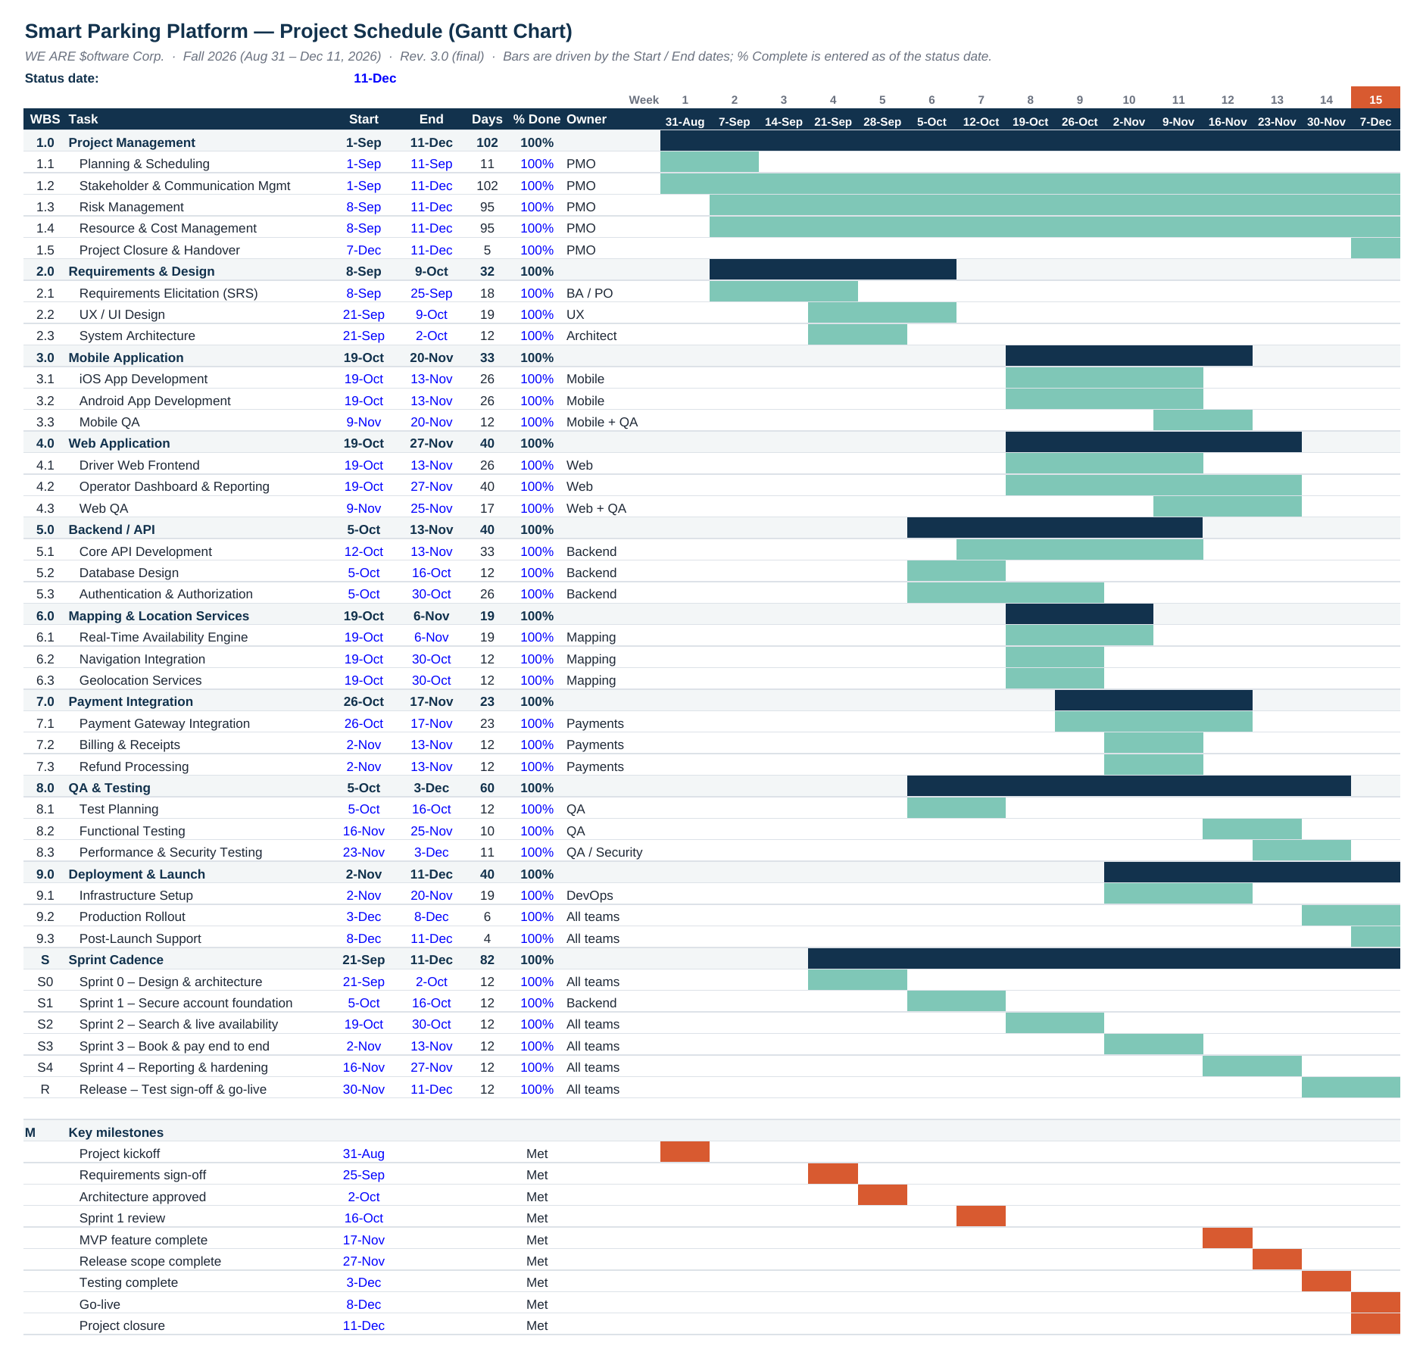
Figure 2. Final project schedule at closure, December 11, 2026. All tasks are complete (light teal); navy bars are work packages and orange marks milestone weeks.

SECTION 6

Product Backlog, User Stories and Sprints
Development follows Scrum with two-week sprints. The product backlog is maintained on the team's Trello board, which has one backlog list per category (Backlog – Login, Backlog – UI, Backlog – Backend, and Backlog – Reporting), a list for the current sprint's backlog headed by its sprint goal card, and a Done list. Every card carries a color label for its category. At sprint planning, cards move from the category backlogs into the sprint list, and they move to Done when they meet the Definition of Done. Items are prioritized with MoSCoW and estimated in Fibonacci story points.
53  Backlog items | 246  Story points | 39  Sprint 1 velocity | 17  Points deferred (Could)

6.1 Backlog updates in this version
- Four items added: UI-17 city data portal, BE-17 fallback mapping provider, BE-18 availability estimates for non-sensor facilities, and BE-19 load testing and autoscaling. BE-17 to BE-19 are responses to risks T-01, T-02, and T-04.
- Every item is assigned to a sprint. Six Could-have items (17 points) are deferred to a post-launch release to protect the go-live date.
- BE-14 (audit logging) carried over from Sprint 1 into Sprint 2.

6.2 Product backlog
Login and access (6 items, 26 points)
ID | Backlog item | Persona | Priority | Pts | Sprint
LG-01 | Driver account registration (email/phone + password) | Driver | Must | 5 | Done (Sprint 1)
LG-02 | Login with email and password for drivers and operators | All users | Must | 3 | Done (Sprint 1)
LG-03 | Password reset via emailed link | All users | Must | 3 | Done (Sprint 1)
LG-04 | Multi-factor authentication (SMS or authenticator app) | All users | Should | 5 | Sprint 2
LG-05 | Role-based access control (Driver / Operator / Admin) | All users | Must | 8 | Done (Sprint 1)
LG-06 | Session timeout and secure logout | All users | Must | 2 | Done (Sprint 1)
Table 14. Login and access backlog.
User interface for drivers, operators, and the city (17 items, 69 points)
ID | Backlog item | Persona | Priority | Pts | Sprint
UI-01 | Driver home screen with destination search bar | Driver | Must | 3 | Sprint 2
UI-02 | Interactive map with available garage pins | Driver | Must | 5 | Sprint 2
UI-03 | Garage detail screen (price, hours, live availability) | Driver | Must | 3 | Sprint 2
UI-04 | Reservation booking screen with date/time picker | Driver | Must | 5 | Sprint 3
UI-05 | Checkout and payment screen | Driver | Must | 5 | Sprint 3
UI-06 | Reservation confirmation with QR entry code | Driver | Must | 3 | Sprint 3
UI-07 | My Reservations screen (active and history) | Driver | Must | 3 | Sprint 3
UI-08 | Digital receipt view and download | Driver | Must | 2 | Sprint 3
UI-09 | Driver notification center | Driver | Should | 3 | Sprint 3
UI-10 | Driver profile, saved vehicles, and payment methods | Driver | Should | 3 | Sprint 4
UI-11 | Operator dashboard home with live occupancy overview | Operator | Must | 8 | Sprint 3
UI-12 | Operator facility listing management screen | Operator | Must | 5 | Sprint 2
UI-13 | Operator pricing and rate editor | Operator | Must | 5 | Sprint 3
UI-14 | Operator space availability and block-off controls | Operator | Must | 5 | Sprint 3
UI-15 | Operator reservation lookup for on-site staff | Operator | Should | 3 | Sprint 4
UI-16 | Operator staff account management screen | Operator | Could | 3 | Post-launch
UI-17 | City read-only data portal (new) | City | Should | 5 | Sprint 4
Table 15. User interface backlog.
Backend processes (19 items, 108 points)
ID | Backlog item | Persona | Priority | Pts | Sprint
BE-01 | Database schema (users, facilities, spaces, reservations, payments) | Both | Must | 8 | Done (Sprint 1)
BE-02 | Authentication API (register, login, token issuance) | Both | Must | 5 | Done (Sprint 1)
BE-03 | Facility search API by location and radius | Driver | Must | 5 | Sprint 2
BE-04 | Real-time space availability service | Both | Must | 13 | Sprint 2
BE-05 | Reservation API (create, hold, confirm) | Driver | Must | 8 | Sprint 2
BE-06 | Scheduled job to release expired unpaid holds | Both | Must | 3 | Sprint 2
BE-07 | Cancellation and refund processing | Both | Must | 5 | Sprint 3
BE-08 | Payment gateway integration (tokenized payments) | Driver | Must | 8 | Sprint 3
BE-09 | Receipt generation service | Driver | Must | 3 | Sprint 3
BE-10 | Notification service (push, email, SMS) | Both | Should | 5 | Sprint 3
BE-11 | Mapping and navigation API integration | Driver | Must | 5 | Sprint 2
BE-12 | Operator dynamic pricing rules engine | Operator | Should | 8 | Sprint 4
BE-13 | Facility onboarding and address geocoding | Operator | Must | 3 | Sprint 2
BE-14 | Audit logging for admin and payment actions | Both | Must | 3 | Sprint 2
BE-15 | Encryption of personal data at rest and in transit | Both | Must | 5 | Done (Sprint 1)
BE-16 | API rate limiting and health monitoring | Both | Should | 3 | Sprint 4
BE-17 | Fallback mapping provider and facility data cache (new) | Both | Should | 5 | Sprint 4
BE-18 | Reservation-based availability estimate for non-sensor facilities (new) | Both | Must | 8 | Sprint 2
BE-19 | Load-test harness and autoscaling configuration (new) | Both | Should | 5 | Sprint 4
Table 16. Backend backlog.
Reporting (11 items, 43 points)
ID | Backlog item | Persona | Priority | Pts | Sprint
RP-01 | Operator occupancy report by hour and day | Operator | Must | 5 | Sprint 3
RP-02 | Operator revenue report by facility and date range | Operator | Must | 5 | Sprint 3
RP-03 | Operator peak-hour utilization heatmap | Operator | Should | 8 | Sprint 4
RP-04 | Operator cancellation and no-show report | Operator | Should | 3 | Sprint 4
RP-05 | Operator average stay duration report | Operator | Could | 3 | Post-launch
RP-06 | Export any operator report to CSV or PDF | Operator | Should | 3 | Sprint 4
RP-07 | Scheduled weekly report emails to operators | Operator | Could | 3 | Post-launch
RP-08 | Driver monthly parking spend summary | Driver | Could | 3 | Post-launch
RP-09 | Driver parking history export for expense reports | Driver | Could | 2 | Post-launch
RP-10 | Driver frequent locations summary | Driver | Could | 3 | Post-launch
RP-11 | Anonymized occupancy report for city transportation departments | City | Should | 5 | Sprint 4
Table 17. Reporting backlog.

6.3 Sprint 1 review (October 5 – 16, 2026)
Sprint goal: secure account foundation — users can register, log in, and reset passwords with role-based access, on top of an encrypted core data model.
8 / 9  Items completed | 39 / 42  Points completed | 93%  Commitment met | 0  Critical defects

ID | Item | Team | Points | Status
LG-01 | Driver account registration | Backend / API + Mobile | 5 | Done
LG-02 | Login for drivers and operators | Backend / API | 3 | Done
LG-03 | Password reset via emailed link | Backend / API | 3 | Done
LG-05 | Role-based access control | Backend / API | 8 | Done
LG-06 | Session timeout and secure logout | Web + Mobile | 2 | Done
BE-01 | Core database schema | Backend / API | 8 | Done
BE-02 | Authentication API | Backend / API | 5 | Done
BE-14 | Audit logging for admin and payment actions | Backend / API | 3 | Carried over
BE-15 | Encryption of personal data at rest and in transit | Backend / API | 5 | Done
Table 18. Sprint 1 results.
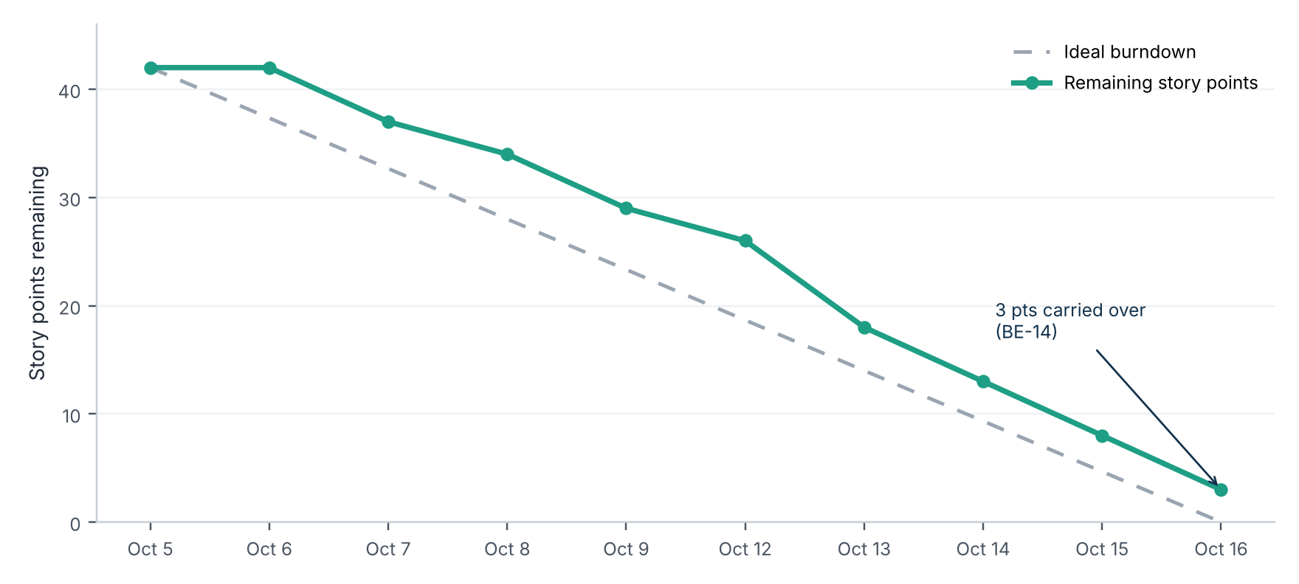
Figure 3. Sprint 1 burndown.
The sprint goal was met. Audit logging (BE-14) was carried over because it depended on the final role model from LG-05, which completed late in the sprint. Sprint 1 was delivered by the Backend/API team alone while the other teams finished design; from Sprint 2 all six delivery teams are active, so planned capacity rises accordingly.
Retrospective
- Went well: a single sprint goal kept everyone aligned; the Trello board gave stakeholders real-time visibility.
- To improve: the dependency between audit logging and role-based access was missed at planning; two items lacked acceptance criteria.
- Actions: dependency check added to sprint planning; no item enters a sprint without acceptance criteria (Definition of Ready).

6.4 Sprint 2 plan and user stories (October 19 – 30, 2026)
Sprint goal: a driver can search for parking and see live availability on the map, with the reservation hold API ready for checkout. Commitment: 13 stories, 69 points across five teams.
ID | User story | Acceptance criteria | Pts
BE-14 | As an administrator, I want every admin and payment action logged so that disputes and audits can be traced. | Each log entry records actor, action, target, and timestamp; entries cannot be edited or deleted. | 3
LG-04 | As an operator, I want multi-factor authentication so that my facility controls are protected. | MFA is mandatory for Operator and Admin roles and optional for Drivers; supports SMS and authenticator apps. | 5
BE-03 | As a driver, I want to search for parking near my destination so that I find options quickly. | Results within the selected radius return in under 2 seconds (P95), sorted by distance. | 5
BE-04 | As a driver, I want live space counts so that I don't drive to a full garage. | Counts shown are no more than 30 seconds old; sensor feeds and operator updates both supported. | 13
BE-18 | As a driver, I want availability at facilities without sensors so that I can still choose them. | Estimated counts are derived from reservations and operator updates and labeled "estimated". | 8
BE-05 | As a driver, I want to hold a space while I pay so that it isn't taken during checkout. | A hold is created for the chosen window and reserved for 10 minutes; double-booking is prevented. | 8
BE-06 | As an operator, I want unpaid holds released automatically so that inventory isn't blocked. | Holds expire after 10 minutes, the space returns to inventory, and the driver is notified. | 3
BE-13 | As an operator, I want my facility address verified so that drivers are routed correctly. | Addresses are geocoded on submission; invalid addresses are rejected with a clear message. | 3
BE-11 | As a driver, I want directions to my garage so that I arrive without searching. | Tapping Navigate opens turn-by-turn directions to the facility entrance. | 5
UI-01 | As a driver, I want a home screen with a destination search bar so that I can start a search in one tap. | Search bar supports address and place names with autocomplete; location shortcut available. | 3
UI-02 | As a driver, I want available garages shown on a map so that I can compare locations at a glance. | Pins show price and space count; the map refreshes as availability changes. | 5
UI-03 | As a driver, I want a garage detail screen so that I can check price, hours, and availability before booking. | Shows all-inclusive price, hours, live or estimated availability, and a Reserve button. | 3
UI-12 | As an operator, I want to manage my facility listing so that drivers see accurate information. | Operators can create, edit, and deactivate listings; changes appear to drivers within 60 seconds. | 5
Table 19. Sprint 2 user stories and acceptance criteria.

6.5 Definition of Ready and Definition of Done
An item is ready for a sprint when it:
- is written as a user story with acceptance criteria;
- is estimated and traced to a functional requirement (Section 3.3);
- has no unresolved dependency on another item, team, or third party.
An item is done when it:
- meets all acceptance criteria and passes code review;
- has passing automated tests and no open critical or high defects;
- is deployed to the integration environment and demonstrated at the sprint review.
SECTION 7

Risk Management
Risks are identified in four categories — technical, schedule, financial, and people — and scored on probability and impact from 1 (very low) to 5 (very high). The score (probability × impact) sets the level: High 12–25, Medium 6–11, Low 1–5. Each risk has an owner, a trigger that signals it is occurring, and a response strategy (avoid, mitigate, transfer, or accept). The register is reviewed weekly in the Thursday Scrum of Scrums, and responses are funded from the contingency reserve in Section 10.
16  Risks identified | 7  High | 9  Medium | $78,640  Contingency reserve

7.1 Risk identification by category
Technical risks
- T-01 Mapping provider outage or rate limits degrade search and navigation.
- T-02 Facilities without sensors report inaccurate availability.
- T-03 Payment integration and PCI scope add complexity.
- T-04 Peak-event demand overloads the availability service.
Schedule risks
- S-01 Scope growth threatens the fixed December 8 go-live.
- S-02 Payment processor certification is delayed.
- S-03 Cross-team integration defects surface late.
- S-04 Estimates miss dependencies, causing carry-over.
Financial risks
- F-01 Mapping and geolocation API usage costs exceed estimate.
- F-02 Real-time polling drives cloud costs above plan.
- F-03 Penetration test findings require unplanned remediation.
- F-04 Sustained overtime or added contractors raise labor cost in the November peak.
People risks
- P-01 Loss of a single specialist (geospatial or payments).
- P-02 Team burnout during the parallel October–November peak.
- P-03 City stakeholders are slow to approve data sharing.
- P-04 Operator staff resist new tools, limiting adoption.

7.2 Probability–impact matrix
Probability 5
Probability 4 |  | S-04 |  |  | T-02
Probability 3 |  | F-01 | S-03  F-02  P-02  P-03 | T-01  T-03  T-04  P-04 | S-01  S-02
Probability 2 |  |  | F-03 | F-04 | P-01
Probability 1
 | Impact 1 | Impact 2 | Impact 3 | Impact 4 | Impact 5

Figure 4. Risk heat map. Red cells are high risks, amber medium, green low.

7.3 Risk register
ID | Category | Risk | Trigger | P | I | Score | Level | Strategy | Response | Owner | Status
T-01 | Technical | Mapping provider outage or rate limits degrade search and navigation. | API error rate above 2% or quota alerts | 3 | 4 | 12 | High | Mitigate | Cache facility data; contract a secondary provider (BE-17). | Mei Tanaka | Closed
T-02 | Technical | Facilities without sensors report inaccurate availability. | Pilot mismatch reports above 5% | 4 | 5 | 20 | High | Mitigate | Reservation-based estimates labeled "estimated" (BE-18); launch with sensor-equipped pilot garages. | Omar Haddad | Realized – resolved
T-03 | Technical | Payment integration and PCI scope add complexity. | Card data found in any platform log or store | 3 | 4 | 12 | High | Transfer | Tokenized processor keeps card data off platform servers; PCI scope limited to SAQ A. | Victor Alvarez | Closed
T-04 | Technical | Peak-event demand overloads the availability service. | P95 latency above 2 s in load tests | 3 | 4 | 12 | High | Mitigate | Load-test harness and autoscaling (BE-19) before Sprint 4 exit. | Ivan Petrov | Closed
S-01 | Schedule | Scope growth threatens the fixed December 8 go-live. | Sprint commitments exceed capacity two sprints in a row | 3 | 5 | 15 | High | Avoid | MoSCoW priorities; change control through the PM; Could items deferred to post-launch. | Priya Raman | Closed
S-02 | Schedule | Payment processor certification is delayed. | Certification not requested by Nov 6 | 3 | 5 | 15 | High | Mitigate | Sandbox from Oct 26; submit certification in Sprint 3; fallback launch with one card network. | Victor Alvarez | Realized – resolved
S-03 | Schedule | Cross-team integration defects surface late. | More than 5 integration defects open at sprint review | 3 | 3 | 9 | Medium | Mitigate | Shared integration environment from Sprint 2; API contract tests in CI. | Grace Liu | Closed
S-04 | Schedule | Estimates miss dependencies, causing carry-over. | Any item carried over | 4 | 2 | 8 | Medium | Mitigate | Dependency check at sprint planning; enforce the Definition of Ready. | Priya Raman | Realized – resolved
F-01 | Financial | Mapping and geolocation API usage costs exceed estimate. | Monthly API spend 20% over plan | 3 | 2 | 6 | Medium | Mitigate | Usage caps and billing alerts; negotiate a tiered plan. | Priya Raman | Closed
F-02 | Financial | Real-time polling drives cloud costs above plan. | Cloud spend 15% over monthly plan | 3 | 3 | 9 | Medium | Mitigate | Event-driven updates instead of polling; cloud budget alerts. | Ivan Petrov | Closed
F-03 | Financial | Penetration test findings require unplanned remediation. | Any critical or high finding | 2 | 3 | 6 | Medium | Accept | Funded from contingency reserve; fixes prioritized in the release window. | Fatima Noor | Realized – resolved
F-04 | Financial | Sustained overtime or added contractors raise labor cost in the November peak. | Labor cost variance above 10% at month close | 2 | 4 | 8 | Medium | Mitigate | Monthly cost review against baseline; capacity planned at 80%. | Anas Altaf | Closed
P-01 | People | Loss of a single specialist (geospatial or payments). | Unplanned absence over 3 days | 2 | 5 | 10 | Medium | Mitigate | Pairing and documentation; Omar Haddad backs up mapping, Jake Turner backs up payments. | Priya Raman | Closed
P-02 | People | Team burnout during the parallel October–November peak. | Two sprints of overtime or falling morale scores | 3 | 3 | 9 | Medium | Mitigate | Sustainable pace, no weekend work, retrospective follow-up. | Priya Raman | Realized – resolved
P-03 | People | City stakeholders are slow to approve data sharing. | No anonymization sign-off by Nov 13 | 3 | 3 | 9 | Medium | Mitigate | Monthly steering committee; anonymization standard agreed early. | Anas Altaf | Realized – resolved
P-04 | People | Operator staff resist new tools, limiting adoption. | Fewer than 10 pilot facilities committed by Nov 20 | 3 | 4 | 12 | High | Mitigate | Monthly operator advisory sessions, training, and a pilot program. | Marcus Bell | Closed
Table 20. Risk register (16 entries) with final status at project close, December 11, 2026.

SECTION 8

Communication Plan
The communication plan sets how often each team and stakeholder group meets, what each meeting produces, and how project status is reported. Team-level meetings keep delivery moving; program-level meetings handle dependencies, risks, and decisions; steering and advisory meetings keep the sponsor, city departments, and operators engaged.

8.1 Program meeting cadence
Meeting | Participants | Frequency | Owner | Output
Daily stand-up | Each delivery team | Daily, 15 min (times in 8.2) | Team lead | Blockers raised; board updated
Scrum of Scrums | PM, team leads, architect | Tue & Thu, 30 min | Priya Raman | Cross-team dependencies and risks
Backlog refinement | PO, BA, team leads | Weekly, Wed, 60 min | Marcus Bell | Ready stories for next sprint
Sprint planning | All teams, PO, PM | Every 2 weeks, Monday, 2 hr | Marcus Bell | Sprint goal and sprint backlog
Sprint review / demo | Teams, PO, sponsor, operator and city reps | Every 2 weeks, Friday, 60 min | Marcus Bell | Demo feedback; backlog updates
Sprint retrospective | Each team | Every 2 weeks, Friday, 45 min | Priya Raman | Improvement actions
Weekly status meeting | Sponsor, PM, PO | Weekly, Monday, 30 min | Priya Raman | RAG status, decisions needed
Risk review | PM, team leads, risk owners | Weekly, in Thursday Scrum of Scrums | Priya Raman | Updated risk register
Architecture & security review | Architect, security, team leads | Every 2 weeks, Wed, 60 min | Daniel Okafor | Design decisions logged
Steering committee | CTO, PM, PO, city reps, finance | Monthly, first Tuesday, 60 min | Anas Altaf | Budget, milestone, and scope decisions
Operator advisory session | PO, BA, UX, operator reps | Monthly, 60 min | Marcus Bell | Operator feedback into backlog
Table 21. Program-level meetings.

8.2 Meeting cadence per team
Team | Lead | Daily stand-up | Team-specific syncs | Key interfaces
Mobile | Lucas Moreau | 9:30 AM | UX design sync (Tue) | Backend / API, Mapping
Web | Ryan Chen | 9:45 AM | UX design sync (Tue); operator advisory (monthly) | Backend / API, Reporting
Backend / API | Omar Haddad | 9:15 AM | API contract review (Wed) | All teams
Mapping | Mei Tanaka | 10:00 AM | Mapping provider check-in (biweekly) | Backend / API, Mobile
Payments | Victor Alvarez | 10:00 AM | Processor and PCI check-in (weekly) | Backend / API, Finance
QA | Grace Liu | 10:15 AM | Defect triage (Tue & Thu) | All teams
DevOps & Security | Ivan Petrov / Fatima Noor | 10:30 AM | Environment and security sync (Mon) | All teams
PMO | Priya Raman | 8:45 AM | Weekly status (Mon); steering (monthly) | Sponsor, stakeholders
Table 22. Meeting cadence for each delivery team.

8.3 Reporting methods
Report | Audience | Frequency | Format / channel | Owner
Weekly status report (RAG) | Sponsor, PO, team leads | Weekly, Monday | Email summary + PDF in shared drive | Priya Raman
Sprint board and burndown | Teams, PO, PM | Live | Trello / Jira board | Team leads
Sprint review summary | All stakeholders | Every 2 weeks | Demo recording + summary email | Marcus Bell
Risk register | PM, risk owners, sponsor | Updated weekly | Shared register (Section 7) | Priya Raman
Budget and cash-flow report | CTO, finance | Monthly | Excel workbook (cost plan vs. actual) | Priya Raman
Steering committee deck | Steering committee | Monthly | Slide deck + decision log | Anas Altaf
Release notes | Operators, drivers, city | Each release | In-app notice + email | Marcus Bell
Table 23. Project reports and distribution.

8.4 Escalation path
- Level 1 – Team: blockers are raised at stand-up and resolved by the team lead within one business day.
- Level 2 – Program: unresolved or cross-team issues go to the PM, who resolves them within two business days or at the next Scrum of Scrums.
- Level 3 – Executive: issues affecting scope, schedule milestones, budget, or compliance go to the CTO and, if needed, the steering committee.

8.5 Communication tools
- Trello / Jira for the backlog, sprint boards, and burndown.
- Microsoft Teams with a channel per team and a program channel for announcements.
- Shared drive for the project plan, status reports, risk register, and cost workbook.
- Email for formal status reports, steering decisions, and external stakeholders.
SECTION 9

Roles, Resources and Responsibilities
The project is staffed by 18 people across leadership, project management, design, six delivery teams, DevOps, and security. All names are fictional. Skill levels drive the loaded hourly rates used in the cost plan (Section 10), and monthly allocations follow the schedule: design-heavy in September, full delivery in October and November, and test and release in December.

9.1 Project organization
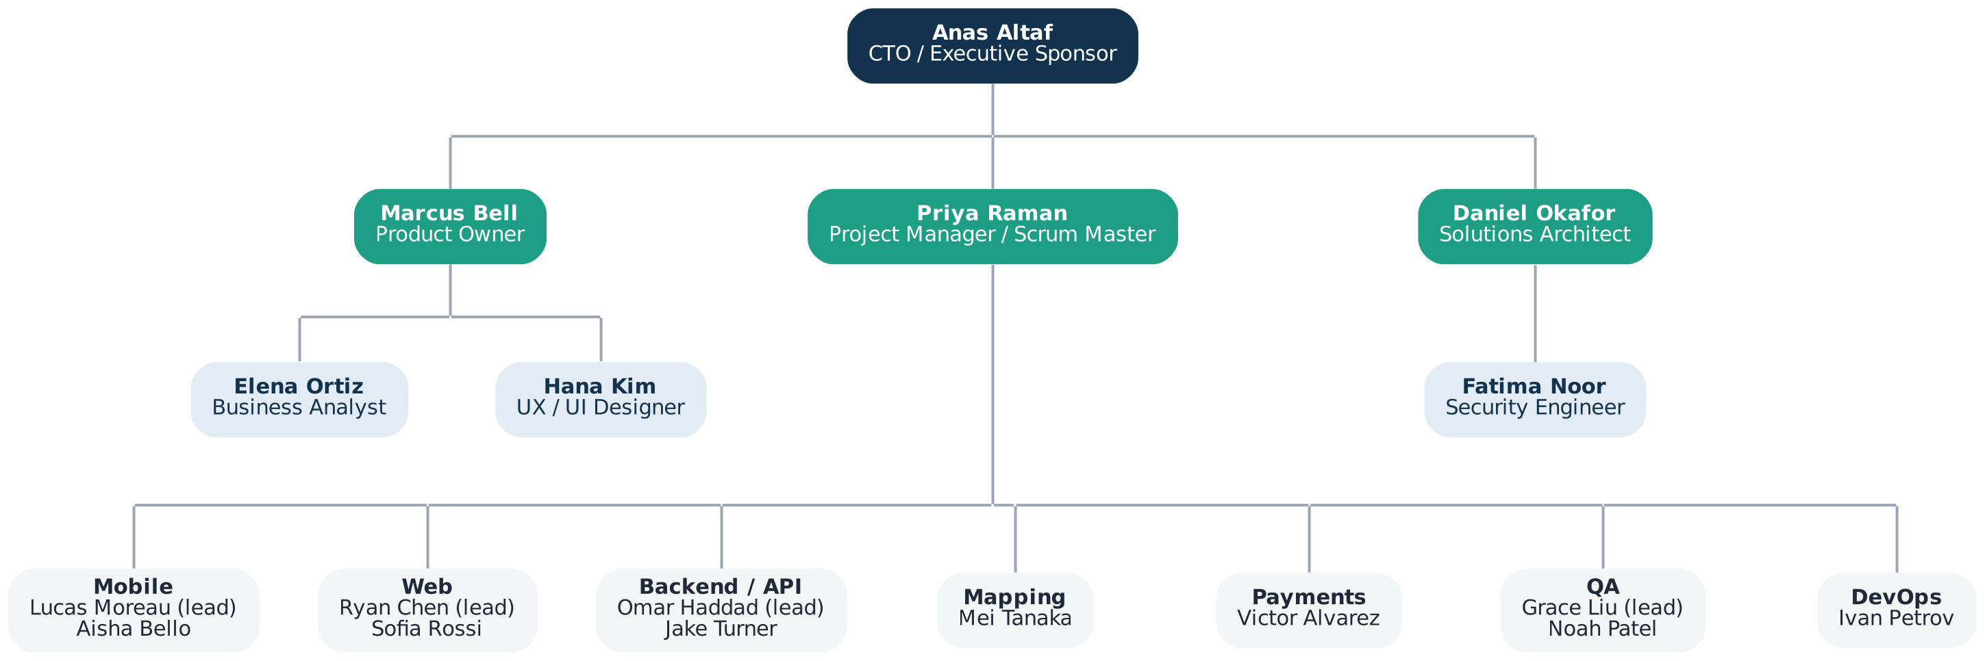
Figure 5. Project organization chart.

9.2 Roles and resources
Name | Role | Team | Skill | Avg. alloc. | Responsibilities
Anas Altaf | CTO / Executive Sponsor | Leadership | Expert | 20% | Owns the business case and budget; chairs the steering committee; final escalation point.
Priya Raman | Project Manager / Scrum Master | PMO | Senior | 100% | Schedule, risk, cost, and communication management; facilitates Scrum events.
Marcus Bell | Product Owner | PMO | Senior | 100% | Owns and prioritizes the product backlog; accepts completed work.
Elena Ortiz | Business Analyst | PMO | Mid | 69% | Requirements elicitation, SRS, user stories, and acceptance criteria.
Daniel Okafor | Solutions Architect | Architecture | Expert | 44% | System architecture, technical standards, and design reviews.
Hana Kim | UX / UI Designer | Design | Senior | 63% | Wireframes, prototypes, and the design system for driver and operator apps.
Lucas Moreau | Mobile Lead (iOS) | Mobile | Senior | 69% | iOS app delivery; mobile technical lead.
Aisha Bello | Android Developer | Mobile | Mid | 69% | Android app delivery.
Ryan Chen | Web Lead (Frontend) | Web | Senior | 69% | Driver web app and operator dashboard; web technical lead.
Sofia Rossi | Frontend Developer | Web | Junior | 63% | Operator dashboard screens and reporting views.
Omar Haddad | Backend Lead | Backend / API | Senior | 75% | Core API, data model, and authentication; backend technical lead.
Jake Turner | Backend Developer | Backend / API | Mid | 69% | Reservation, notification, and reporting services.
Mei Tanaka | Geospatial Engineer | Mapping | Senior | 63% | Real-time availability engine, geolocation, and navigation integration.
Victor Alvarez | Payments Engineer | Payments | Senior | 56% | Payment gateway, billing, refunds, and PCI compliance.
Grace Liu | QA Lead | QA | Senior | 81% | Test strategy, functional testing, and release sign-off.
Noah Patel | QA Automation Engineer | QA | Mid | 63% | Automated regression and performance test suites.
Ivan Petrov | DevOps Engineer | DevOps | Senior | 69% | Environments, CI/CD, monitoring, and production rollout.
Fatima Noor | Security Engineer | Security | Senior | 56% | Security architecture, encryption, and penetration-test coordination.
Table 24. Project roles, skill levels, and average allocation.

9.3 Resource allocation by month
Name | Role | Sep | Oct | Nov | Dec | Hours
Anas Altaf | CTO / Executive Sponsor | 20% | 20% | 20% | 20% | 112
Priya Raman | Project Manager / Scrum Master | 100% | 100% | 100% | 100% | 560
Marcus Bell | Product Owner | 100% | 100% | 100% | 100% | 560
Elena Ortiz | Business Analyst | 100% | 100% | 50% | 25% | 420
Daniel Okafor | Solutions Architect | 75% | 50% | 25% | 25% | 260
Hana Kim | UX / UI Designer | 100% | 100% | 50% | 0% | 400
Lucas Moreau | Mobile Lead (iOS) | 25% | 100% | 100% | 50% | 400
Aisha Bello | Android Developer | 25% | 100% | 100% | 50% | 400
Ryan Chen | Web Lead (Frontend) | 25% | 100% | 100% | 50% | 400
Sofia Rossi | Frontend Developer | 0% | 100% | 100% | 50% | 360
Omar Haddad | Backend Lead | 50% | 100% | 100% | 50% | 440
Jake Turner | Backend Developer | 25% | 100% | 100% | 50% | 400
Mei Tanaka | Geospatial Engineer | 25% | 100% | 100% | 25% | 380
Victor Alvarez | Payments Engineer | 25% | 75% | 100% | 25% | 340
Grace Liu | QA Lead | 50% | 75% | 100% | 100% | 440
Noah Patel | QA Automation Engineer | 0% | 50% | 100% | 100% | 320
Ivan Petrov | DevOps Engineer | 25% | 50% | 100% | 100% | 360
Fatima Noor | Security Engineer | 25% | 50% | 50% | 100% | 280
Total FTE |  | 8.0 | 14.7 | 14.9 | 10.2 | 6,832
Table 25. Monthly allocation (% of full time). Hours at 100%: 160 per month, 80 in December.

9.4 RACI matrix
R = Responsible (does the work) · A = Accountable (one owner per activity) · C = Consulted · I = Informed. R/A means the same role does the work and owns the result.
Activity | Sponsor  (A. Altaf) | PM  (P. Raman) | PO  (M. Bell) | BA  (E. Ortiz) | Architect  (D. Okafor) | UX  (H. Kim) | Dev leads &  engineers | QA  (G. Liu) | DevOps  (I. Petrov) | Security  (F. Noor)
Project charter & kickoff | A | R | C | C | C | I | I | I | I | I
Requirements & SRS | I | C | A | R | C | C | C | C | I | C
Product backlog & prioritization | I | C | A | R | C | I | C | C | I | I
UX / UI design | I | I | A | C | C | R | C | C | I | I
System architecture | I | I | C | I | R/A | C | C | C | C | C
Sprint planning & execution | I | A | C | I | C | C | R | C | C | I
Mobile, web & backend development | I | I | C | I | C | C | R/A | C | C | C
Mapping & payment integration | I | I | C | I | A | I | R | C | C | C
Security & compliance (PCI, privacy) | A | I | I | I | C | I | C | C | C | R
Testing & acceptance | I | I | A | C | I | I | C | R | C | C
Deployment & go-live | A | C | C | I | C | I | C | C | R | C
Risk management | I | R/A | C | I | C | I | C | C | C | C
Communication & status reporting | I | R/A | C | I | I | I | I | I | I | I
Budget & cost control | A | R | I | I | I | I | I | I | I | I
Change control | A | R | C | C | C | I | C | I | I | I
Stakeholder & operator engagement | I | C | A | R | I | C | I | I | I | I
Table 26. RACI matrix for key project activities.

SECTION 10

Cost Management
The cost plan is built bottom-up. Labor cost is each role's loaded hourly rate multiplied by its monthly hours (allocation × 160 hours, or 80 hours in December). Non-labor costs are PMO estimates for infrastructure, third-party services, software, equipment, security testing, and training. A 10% contingency reserve funds the risk responses in Section 7, and a 5% management reserve, controlled by the CTO, covers unidentified risks. Although the development budget is theoretically unlimited, all spending is controlled against this baseline. The full model, with formulas, is in Smart_Parking_Schedule_and_Cost.xlsx.
$908,292  Total budget | $865,040  Cost baseline | $717,700  Labor | $68,700  Non-labor

10.1 Labor cost by role
Name | Role | Skill | Rate / hr | Hours | Total
Anas Altaf | CTO / Executive Sponsor | Expert | $200 | 112 | $22,400
Priya Raman | Project Manager / Scrum Master | Senior | $110 | 560 | $61,600
Marcus Bell | Product Owner | Senior | $105 | 560 | $58,800
Elena Ortiz | Business Analyst | Mid | $85 | 420 | $35,700
Daniel Okafor | Solutions Architect | Expert | $140 | 260 | $36,400
Hana Kim | UX / UI Designer | Senior | $95 | 400 | $38,000
Lucas Moreau | Mobile Lead (iOS) | Senior | $115 | 400 | $46,000
Aisha Bello | Android Developer | Mid | $90 | 400 | $36,000
Ryan Chen | Web Lead (Frontend) | Senior | $115 | 400 | $46,000
Sofia Rossi | Frontend Developer | Junior | $65 | 360 | $23,400
Omar Haddad | Backend Lead | Senior | $115 | 440 | $50,600
Jake Turner | Backend Developer | Mid | $90 | 400 | $36,000
Mei Tanaka | Geospatial Engineer | Senior | $120 | 380 | $45,600
Victor Alvarez | Payments Engineer | Senior | $120 | 340 | $40,800
Grace Liu | QA Lead | Senior | $95 | 440 | $41,800
Noah Patel | QA Automation Engineer | Mid | $75 | 320 | $24,000
Ivan Petrov | DevOps Engineer | Senior | $110 | 360 | $39,600
Fatima Noor | Security Engineer | Senior | $125 | 280 | $35,000
Labor total |  |  |  | 6,832 | $717,700
Table 27. Bottom-up labor cost by role.

10.2 Non-labor costs
Item | Category | Sep | Oct | Nov | Dec | Total
Cloud infrastructure (dev, test, prod) | Infrastructure | $2,000 | $3,500 | $6,000 | $9,000 | $20,500
Mapping & geolocation API licensing | Third-party services | – | $1,500 | $2,500 | $3,000 | $7,000
Payment gateway sandbox & PCI certification | Third-party services | – | $500 | $4,000 | $1,500 | $6,000
Software & collaboration tools | Software | $1,800 | $1,800 | $1,800 | $1,800 | $7,200
Mobile test devices (iOS & Android) | Equipment | – | $6,000 | $1,500 | – | $7,500
Third-party penetration test | Security & compliance | – | – | $9,000 | $9,000 | $18,000
Team onboarding & training | Training | $2,500 | – | – | – | $2,500
Non-labor total |  | $6,300 | $13,300 | $24,800 | $24,300 | $68,700
Table 28. Non-labor costs by month.

10.3 Cost plan summary
Cost line | Sep | Oct | Nov | Dec | Total
A. Labor | $138,600 | $245,000 | $248,400 | $85,700 | $717,700
B. Non-labor | $6,300 | $13,300 | $24,800 | $24,300 | $68,700
Direct cost (A + B) | $144,900 | $258,300 | $273,200 | $110,000 | $786,400
Contingency reserve (10%) | $14,490 | $25,830 | $27,320 | $11,000 | $78,640
Cost baseline | $159,390 | $284,130 | $300,520 | $121,000 | $865,040
Management reserve (5%) | $7,970 | $14,206 | $15,026 | $6,050 | $43,252
Total project budget | $167,360 | $298,336 | $315,546 | $127,050 | $908,292
Table 29. Cost plan summary by month.

10.4 Budgeted monthly cash flow
Month | Baseline | Cumulative | % of baseline | Mgmt. reserve | Total budget
Sep 2026 | $159,390 | $159,390 | 18.4% | $7,970 | $167,360
Oct 2026 | $284,130 | $443,520 | 51.3% | $14,206 | $298,336
Nov 2026 | $300,520 | $744,040 | 86.0% | $15,026 | $315,546
Dec 2026 | $121,000 | $865,040 | 100.0% | $6,050 | $127,050
Total | $865,040 |  |  | $43,252 | $908,292
Table 30. Budgeted monthly cash flow.
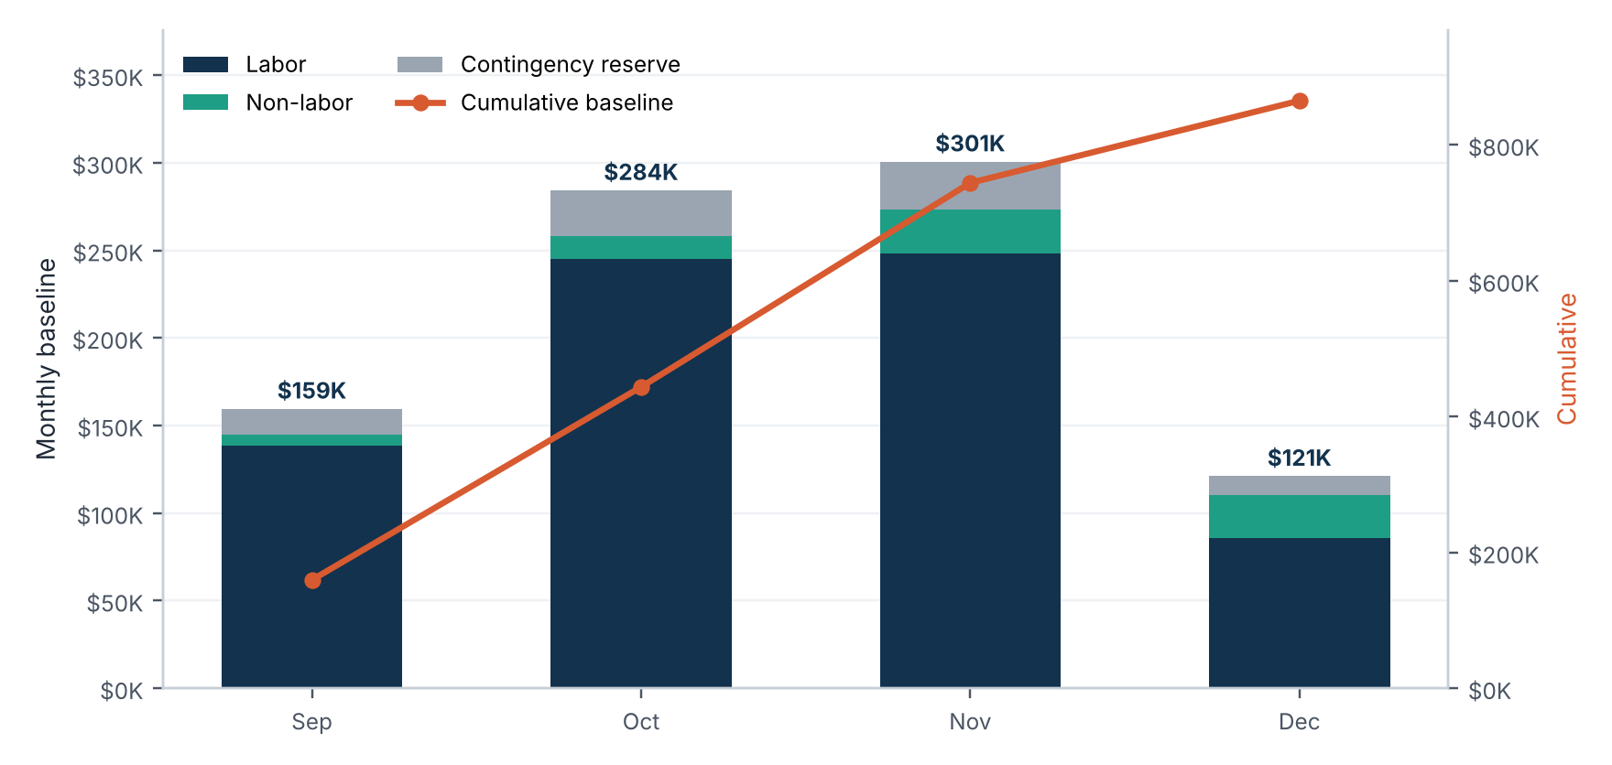
Figure 6. Monthly cost baseline and cumulative spend curve.

10.5 Cost control
- Actual cost is compared with the baseline at each month close and reported to the CTO and finance.
- From Sprint 2, earned value (planned value, earned value, actual cost) is tracked per sprint using the cumulative baseline as planned value.
- A variance above 10% in any month, or any draw on contingency, is escalated to the steering committee.
- Contingency is released by the PM against a specific risk in the register; management reserve is released only by the CTO.
SECTION 11

Project Status Report
Final status at project close on December 11, 2026. Status was reported weekly (Section 8.3); the history table shows how each area was rated at the end of each sprint and at close.
Closed  Project status | Dec 8  Go-live (on plan) | 90%  Backlog points delivered | $829,850  Final cost

Area | Final | Summary at close
Overall | Green | All products live on December 8; project closed December 11 (Section 15).
Schedule | Green | Go-live on plan; MVP milestone two working days late and testing one day late.
Scope | Amber | 90% of backlog points delivered; BE-12 and six Could-have items moved to the post-launch release.
Quality | Green | No critical or high defects open at release; performance, usability, and accessibility targets met.
Cost | Green | $829,850 actual against a $865,040 cost baseline; 55% of contingency used.
Risks | Green | All risks closed; six occurred and were resolved within contingency or schedule buffer (Section 7.3).
Resources | Green | No attrition; team released December 11.
Table 31. Final project status by area.

11.1 Status history
Area | Oct 16 | Oct 30 | Nov 13 | Nov 27 | Dec 11
Overall | Green | Green | Amber | Green | Green
Schedule | Green | Green | Amber | Green | Green
Scope | Green | Green | Green | Amber | Amber
Cost | Green | Green | Green | Green | Green
Risks | Amber | Amber | Red | Amber | Green
Table 32. Status ratings at each sprint review and at close. The November 13 ratings reflect the payment certification delay (risk S-02).

11.2 Closing actions
- Post-launch release backlog handed to the Product Owner: BE-12, additional card networks, and six Could-have items.
- Hypercare support by the delivery teams ended December 11; the operations team owns the platform from that date.
- Final steering committee held December 11 to approve project closure.

SECTION 12

Stakeholder Analysis
Fourteen stakeholders and stakeholder groups were identified and rated on two dimensions: power (their ability to influence the project's scope, resources, or outcome) and interest (how much the project's results affect them). Their position on the power–interest grid sets how closely each is engaged. The analysis was reviewed with the sponsor and is revisited at each monthly steering committee.

12.1 Power–interest grid
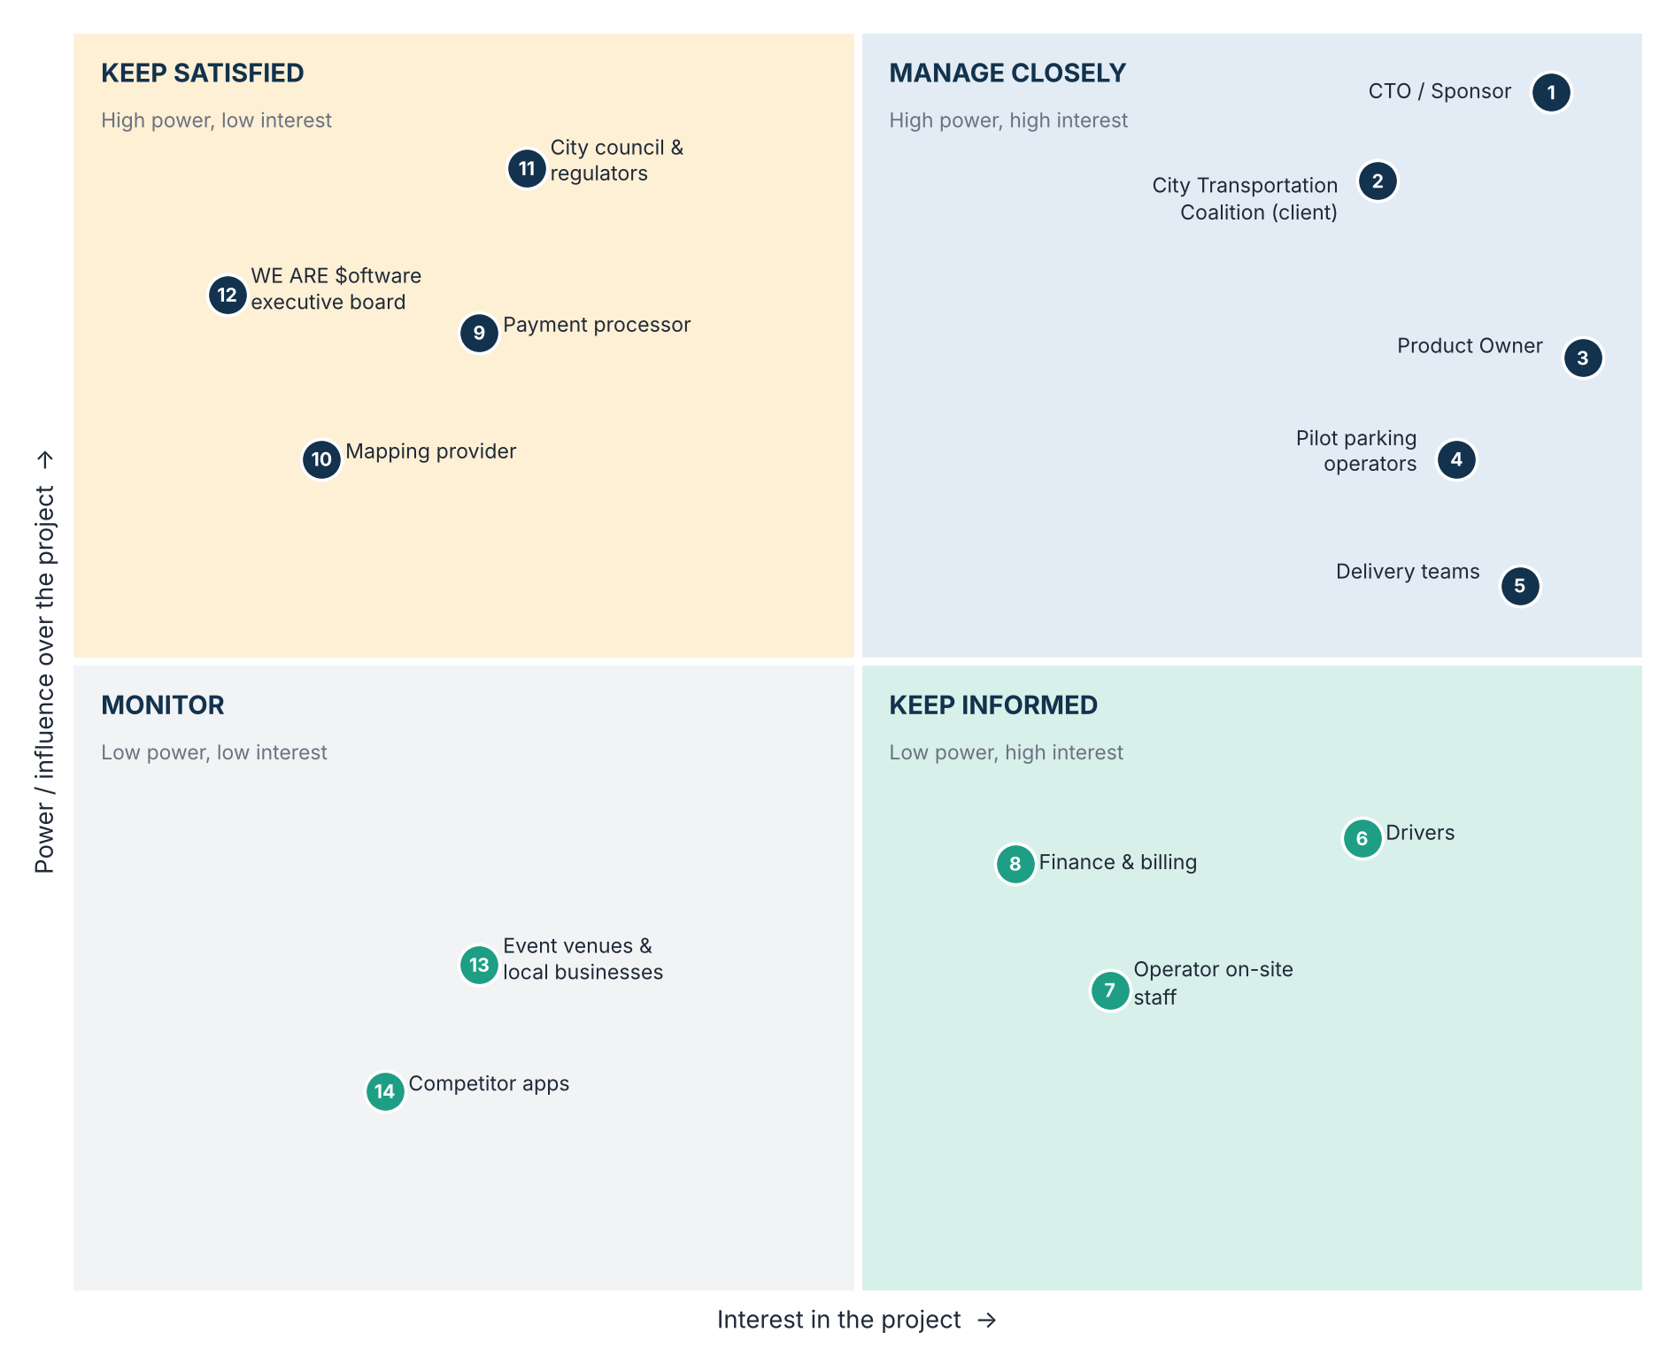
Figure 7. Power–interest grid. Numbers match the stakeholder IDs in Table 33.

12.2 Stakeholder register
ID | Stakeholder | Who | Key interests | Power | Interest | Strategy
S1 | CTO / Sponsor | Anas Altaf, CTO | Delivery on time and within budget; return on investment. | High | High | Manage closely
S2 | City Transportation Coalition (client) | Coalition of city transportation departments | Less downtown congestion; utilization data for planning. | High | High | Manage closely
S3 | Product Owner | Marcus Bell | A product that drivers and operators adopt. | High | High | Manage closely
S4 | Pilot parking operators | Facility owners and managers in the pilot | More bookings and revenue; easy-to-use tools. | Medium | High | Manage closely
S5 | Delivery teams | Mobile, Web, Backend, Mapping, Payments, QA, DevOps | Clear priorities, realistic scope, sustainable pace. | Medium | High | Manage closely
S6 | Drivers | Commuters and visitors who park downtown | Fast search, guaranteed space, upfront price. | Low | High | Keep informed
S7 | Operator on-site staff | Attendants and facility staff | Simple tools that don't slow down entry and exit. | Low | Medium | Keep informed
S8 | Finance & billing | Finance staff (client and WE ARE $oftware) | Accurate ledgers, reconciliation, and refunds. | Low | Medium | Keep informed
S9 | Payment processor | Contracted PCI DSS processor | A compliant integration on its certification timeline. | High | Low | Keep satisfied
S10 | Mapping provider | Contracted mapping and navigation provider | Correct API use within licensed quotas. | Medium | Low | Keep satisfied
S11 | City council & regulators | City council and parking regulators | Compliance with ordinances and privacy law. | High | Low | Keep satisfied
S12 | WE ARE $oftware executive board | WE ARE $oftware executive board | Strategic fit and company reputation. | High | Low | Keep satisfied
S13 | Event venues & local businesses | Event venues and nearby businesses | Easier parking for customers. | Low | Low | Monitor
S14 | Competitor apps | SpotHero, ParkWhiz, ParkMobile, PayByPhone | Protect market share. | Low | Low | Monitor
Table 33. Stakeholder register.

12.3 Engagement strategy by quadrant
Quadrant | Stakeholders | Engagement approach
Manage closely | S1–S5 | Involve in decisions. Weekly or more frequent contact, sprint review demos, and a direct voice in prioritization and change control.
Keep satisfied | S9–S12 | Meet their requirements with little effort on their part. Short, formal updates at agreed milestones; escalate only decisions that need them.
Keep informed | S6–S8 | Regular, two-way updates. Beta access, surveys, training, and release notes so concerns surface early.
Monitor | S13, S14 | Watch for changes in interest or influence; communicate at launch and through public channels.
Table 34. Engagement strategy for each quadrant of the grid.

12.4 Current attitude and engagement plan
ID | Current attitude | Engagement channel
S1 | Champion | Weekly status meeting; monthly steering committee.
S2 | Supportive | Monthly steering committee; sprint review demos.
S3 | Champion | Daily involvement; owns the backlog.
S4 | Neutral → Supportive | Monthly operator advisory sessions; pilot onboarding.
S5 | Supportive | Daily stand-ups; Scrum of Scrums; retrospectives.
S6 | Unaware → Supportive | Beta program, release notes, in-app surveys.
S7 | Resistant → Neutral | Training sessions; quick-reference guides.
S8 | Neutral | Monthly budget report; UAT for finance features.
S9 | Neutral | Weekly integration check-in; certification plan.
S10 | Neutral | Biweekly technical check-in; usage reports.
S11 | Neutral | Briefings through the city coalition; compliance reviews.
S12 | Supportive | Quarterly portfolio review through the CTO.
S13 | Unaware | Launch announcements; partnership outreach after launch.
S14 | Opposed | Competitive monitoring (Section 1).
Table 35. Stakeholder attitude and engagement channels. Meeting details are in the communication plan (Section 8).
Two stakeholder groups need attitude to shift before launch: pilot operators (from neutral to supportive) and operator on-site staff (from resistant to neutral). Both are addressed through the monthly operator advisory session, hands-on training, and the pilot program, and both are tracked as risk P-04 in the risk register.
SECTION 13

Project Charter
The project charter formally authorizes the Smart Parking Platform project and gives the project manager authority to apply organizational resources to it. It was approved at the project kickoff on August 31, 2026.
Project name | Smart Parking Platform
Project sponsor | Anas Altaf, CTO, WE ARE $oftware Corp.
Client | Coalition of mid-sized city transportation departments
Project manager | Priya Raman
Product owner | Marcus Bell
Charter date | August 31, 2026 (approved at project kickoff)
Project dates | August 31 – December 11, 2026; production go-live December 8, 2026
Authorized budget | $908,292 (cost baseline $865,040 plus $43,252 management reserve)

13.1 Purpose and business case
Drivers in mid-sized downtowns spend significant time circling for parking, adding to congestion, while garage operators lack the tools to manage and price their capacity. The city coalition's request for proposals called for one platform that lets drivers find, reserve, and pay for parking in real time, gives operators modern management tools, and gives cities anonymized utilization data. WE ARE $oftware Corp. was selected on the strength of its unified architecture and its ability to commit resources without budget constraints.

13.2 Objectives and success criteria
# | Objective | Success criterion
O1 | Launch driver iOS, Android, and web apps; the operator dashboard; and the city data portal in production. | Live by December 8, 2026
O2 | Prove operator value through a pilot program. | At least 10 facilities onboarded at go-live
O3 | Meet the performance, availability, accessibility, and security requirements in the SRS. | NFR-01 to NFR-12 met at release sign-off
O4 | Deliver within the authorized budget. | Actual cost at or below the cost baseline
O5 | Give the city coalition anonymized utilization data. | City portal live with approved anonymization standard
Table 36. Project objectives and measurable success criteria.

13.3 High-level scope
In scope: driver mobile and web apps, operator dashboard and reporting, city data portal, administration and audit tools, and integration with mapping and payment providers.
Out of scope: hardware installation at facilities, on-street meter integration, and Could-have backlog items deferred to a post-launch release.

13.4 Major deliverables and milestones
Milestone | Date
Project kickoff | Aug 31, 2026
Requirements sign-off | Sep 25, 2026
Architecture approved | Oct 2, 2026
Sprint 1 review | Oct 16, 2026
MVP feature complete | Nov 13, 2026
Release scope complete | Nov 27, 2026
Testing complete | Dec 2, 2026
Go-live | Dec 8, 2026
Table 37. Charter milestones.

13.5 Key assumptions, constraints, and risks
- Constraint: the go-live date is fixed; scope is the lever if the schedule is at risk.
- Assumptions: payment and mapping providers are contracted before Sprint 3; facilities supply occupancy data.
- Top risks: availability accuracy at non-sensor facilities (T-02), payment certification timing (S-02), and operator adoption (P-04). The full register is in Section 7.

13.6 Project manager authority
The project manager may assign project team members, approve sprint plans, release contingency reserve against an identified risk, and approve changes that do not affect a milestone date or the authorized budget. Changes to milestones, the budget, or client-facing scope require sponsor approval through change control.

13.7 Approvals
Name | Role | Decision | Date
Anas Altaf | CTO, Executive Sponsor | Approved | Aug 31, 2026
Priya Raman | Project Manager | Approved | Aug 31, 2026
Marcus Bell | Product Owner | Approved | Aug 31, 2026
City coalition representative | Client | Approved | Aug 31, 2026
Table 38. Project charter approvals.
SECTION 14

Team Charter
The team charter sets how the Smart Parking Platform team works together. It was drafted by the whole team during Sprint 0 (September 21 – October 2, 2026) and is reviewed at the end of each retrospective. Roles and responsibilities are defined in Section 9.

14.1 Team mission
Build a parking platform that drivers trust and operators rely on — delivered on December 8, 2026, at a pace we can sustain.

14.2 Team values
Value | What it means for us
Ownership | We commit to sprint goals as a team and raise problems early instead of hiding them.
Transparency | Work, blockers, and risks are visible on the board and in stand-ups.
Respect | We assume good intent, challenge ideas rather than people, and protect focus time.
Quality | Nothing is done until it meets the Definition of Done (Section 6.5).
Sustainable pace | We plan to 80% of capacity and avoid weekend work.
Table 39. Team values.

14.3 Working agreements
Area | Agreement
Core hours | 10:00 AM – 3:00 PM Central, Monday to Friday; meetings are scheduled inside core hours.
Response times | Teams chat within 4 working hours; email within 1 business day; production incidents within 15 minutes.
Meetings | Every meeting has an agenda and an owner; start and end on time; decisions and actions are posted in the team channel.
Board hygiene | Cards are updated before daily stand-up; every card has an owner, estimate, and acceptance criteria.
Code and reviews | All code goes through pull requests with at least one reviewer; reviews are completed within one working day.
Documentation | Decisions go in the decision log; architecture decisions are recorded in ADRs reviewed by the architect.
Time off | Planned leave is entered in the team calendar at least two weeks ahead and raised at sprint planning.
Table 40. Team working agreements.

14.4 Decision-making
Decision | Decided by | How
Product scope and priority | Marcus Bell (Product Owner) | Consults team leads and the BA.
Technical design and standards | Daniel Okafor (Architect) | Consults team leads and Security.
Sprint commitment | Delivery team | By consensus at sprint planning.
Schedule, resources, and process | Priya Raman (PM) | Escalates milestone changes to the sponsor.
Budget and milestone changes | Anas Altaf (Sponsor) | Steering committee for client-impacting changes.
Table 41. Decision rights.

14.5 Communication norms
- Microsoft Teams for day-to-day communication, with one channel per team and a program channel for announcements.
- Trello / Jira as the single source of truth for work status.
- Cameras on for sprint reviews and retrospectives; stand-ups may be audio only.
- Bad news travels fast: blockers and risks are raised the day they are found.

14.6 Conflict resolution
- Step 1 – the people involved discuss it directly and privately within one working day.
- Step 2 – if unresolved, the team lead facilitates a conversation focused on facts and the project goal.
- Step 3 – if still unresolved, the PM (process or people issues) or the architect (technical issues) decides.
- Step 4 – issues affecting scope, budget, or milestones are escalated to the sponsor (Section 8.4).

14.7 Accountability and recognition
- Sprint commitments and action items are reviewed openly at each retrospective.
- Team members recognize each other's contributions in the program channel and at sprint reviews.
- Repeated breaches of working agreements are raised privately by the team lead, then with the PM.

14.8 Team sign-off
All 18 team members listed in Section 9.2 reviewed and agreed to this charter on October 2, 2026, at the end of Sprint 0.

SECTION 15 · INTERNAL

Project Closure Report
INTERNAL For WE ARE $oftware Corp. internal use only. Not for distribution to the client or external parties.

Project | Smart Parking Platform
Report date | December 11, 2026
Prepared by | Priya Raman, Project Manager
Reviewed by | Anas Altaf, CTO and Executive Sponsor
Classification | Internal

15.1 Executive summary
The Smart Parking Platform went live on December 8, 2026, the date set in the project charter. Drivers can now find, reserve, and pay for parking in real time on iOS, Android, and the web; operators manage facilities, pricing, and reports through the operator dashboard; and the city coalition has anonymized utilization data through its portal. Twelve pilot facilities were onboarded, above the target of ten.
The project finished at $829,850, $35,190 under the cost baseline, after drawing $43,450 of contingency against four named risks. Ninety percent of backlog points were delivered, including every Must-have item. The main shortfalls were a two-day slip of the MVP milestone caused by payment certification, launch with two card networks instead of four, and availability accuracy of 91% at non-sensor facilities against a 95% target. Four of five charter objectives were fully met and one was partially met. The project is recommended for formal closure.
Dec 8  Go-live (on plan) | $829,850  Actual cost | 90%  Backlog points delivered | 12  Pilot facilities

15.2 Results against objectives
# | Objective | Result | Status
O1 | Launch all apps, dashboard, and city portal by Dec 8 | All live on December 8, 2026 | Met
O2 | At least 10 pilot facilities at go-live | 12 facilities onboarded | Met
O3 | NFR-01 to NFR-12 met at release sign-off | 11 of 12 met; payment card coverage limited at launch (see shortfalls) | Partially met
O4 | Actual cost at or below the cost baseline | $829,850 against a $865,040 baseline | Met
O5 | City portal live with approved anonymization | Live December 8; anonymization approved December 4 | Met
Table 42. Results against the project charter objectives.
Schedule
Milestone | Planned | Actual | Variance
Requirements sign-off | Sep 25 | Sep 25 | 0 days
Architecture approved | Oct 2 | Oct 2 | 0 days
Sprint 1 review | Oct 16 | Oct 16 | 0 days
MVP feature complete | Nov 13 | Nov 17 | +2 working days
Release scope complete | Nov 27 | Nov 27 | 0 days
Testing complete | Dec 2 | Dec 3 | +1 day
Go-live | Dec 8 | Dec 8 | 0 days
Table 43. Planned versus actual milestone dates (2026).
Scope and delivery
Sprint | Dates | Committed | Done | Met | Notes
Sprint 1 | Oct 5 – 16 | 42 | 39 | 93% | BE-14 carried over
Sprint 2 | Oct 19 – 30 | 69 | 64 | 93% | BE-18 estimate model (5 pts) carried over
Sprint 3 | Nov 2 – 13 | 75 | 70 | 93% | BE-08 certification tasks carried over
Sprint 4 | Nov 16 – 27 | 56 | 48 | 86% | BE-12 pricing rules engine moved to post-launch
Total |  |  | 221 |  | of 246 backlog points (90%)
Table 44. Sprint delivery summary (story points).
Cost
Cost line | Planned | Actual | Variance
Direct cost (labor and non-labor) | $786,400 | $786,400 | $0
Contingency reserve | $78,640 | $43,450 drawn | $35,190 unused
Cost baseline | $865,040 | $829,850 | $35,190 under
Management reserve | $43,252 | $0 | $43,252 unused
Total budget | $908,292 | $829,850 | $78,442 under
Table 45. Planned versus actual cost.
Risk | Event | Use of contingency | Amount
S-02 | Payment certification delayed | Expedited certification review and extra payments engineering time in Sprint 3 | $9,500
T-02 | Availability accuracy at non-sensor facilities | Two additional weeks of backend work on sensor feeds and the estimate model | $18,400
F-03 | Penetration test findings | Remediation of two high-severity findings before release | $8,750
P-02 | November peak workload | Approved overtime for Mobile and QA during Sprint 4 | $6,800
Table 46. Contingency reserve draws, each linked to a risk in the register.
Quality
Requirement | Target | Result | Status
NFR-01 | Search P95 under 2 s | 1.4 s | Met
NFR-02 | Availability data no more than 30 s old | 22 s average | Met
NFR-04 | 10,000 concurrent users | 12,000 in load test | Met
NFR-05/06 | Encryption; tokenized payments | Passed penetration test after remediation | Met
NFR-09 | WCAG 2.1 AA | Passed audit; 3 minor issues fixed before launch | Met
NFR-10 | Returning driver books in under 60 s | 41 s median in usability test | Met
Table 47. Key non-functional requirement results at release sign-off.

15.3 Achievements
- Go-live on the planned date of December 8, 2026, with all three user-facing products: driver apps, operator dashboard, and city portal.
- 12 pilot facilities onboarded against a target of 10, giving the platform real inventory at launch.
- Completed $35,190 (4.1%) under the cost baseline, using 55% of the contingency reserve and none of the management reserve.
- 221 of 246 backlog points delivered (90%), including every Must-have item.
- Performance and usability targets exceeded: 1.4 s search P95 and a 41-second median booking time.
- No team attrition; average sprint commitment met was 91%.

15.4 Shortfalls
Shortfall | Cause and impact
MVP milestone 2 days late | Payment processor certification took longer than planned (risk S-02). MVP feature complete moved from Nov 13 to Nov 17; buffer in Sprint 4 absorbed the delay.
Limited card networks at launch | The fallback response to S-02 was used: launch with Visa and Mastercard; American Express and Discover follow in the first post-launch release.
Availability accuracy below target | Estimated availability at non-sensor facilities matched audited counts 91% of the time against a 95% target (risk T-02). These facilities remain labeled "estimated".
Dynamic pricing engine deferred | BE-12 (8 points) was not finished in Sprint 4 and moved to post-launch, along with six Could-have items (17 points).
Late city data sign-off | The anonymization standard was approved December 4, leaving four days for city portal acceptance testing (risk P-03).
Table 48. Shortfalls and their causes.

15.5 Lessons learned
Area | Lesson
Third-party dependencies | Certification and contracting with external providers take longer than development. Start them in Sprint 0, not when the integration work begins.
Data quality | Availability accuracy depends on facility data we don't control. Baseline each facility's data quality during onboarding, before building features on it.
Dependency planning | The Sprint 1 carry-over came from a missed dependency. The dependency check added to sprint planning prevented a repeat in later sprints.
Contingency reserve | Funding contingency from the risk register worked: every draw was tied to a named risk, which made approvals fast and traceable.
Stakeholder engagement | Monthly operator advisory sessions turned on-site staff from resistant to neutral and produced 14 backlog changes. Start them earlier on future projects.
Communication cadence | The weekly RAG report and biweekly demos kept the sponsor and client aligned; no escalation reached the steering committee unexpected.
Testing | Load testing in Sprint 4 found two scaling issues with little time to spare. Performance testing should begin by the middle of the build phase.
Table 49. Lessons learned, gathered at the final retrospective on December 10, 2026.

15.6 Recommendations for future projects
# | Recommendation
R1 | Open vendor certification and contract work in the first two weeks of every project with external payment or data providers.
R2 | Reserve a buffer sprint or 10% schedule buffer before any fixed release date.
R3 | Add a data-readiness assessment to the onboarding checklist for any partner that supplies operational data.
R4 | Run performance and security testing continuously from mid-build rather than only in the release window.
R5 | Keep the risk-linked contingency model and the dependency check at sprint planning as standard practice.
R6 | Engage end users who are affected by a new tool (such as on-site staff) from requirements onward, not only at training.
Table 50. Recommendations for future projects.

15.7 Administrative closure
Item | Status
Operations handover | Platform transferred to the WE ARE $oftware operations team on Dec 9 with runbooks, monitoring dashboards, and on-call rota.
Post-launch backlog | BE-12 and six Could-have items (25 points) moved to the post-launch release backlog, owned by the Product Owner.
Contracts | Penetration-test vendor closed; mapping and payment provider contracts transferred to operations.
Documentation | SRS, architecture decision records, runbooks, and this plan archived in the project repository.
Team release | Delivery team released on Dec 11; performance feedback provided to each team member's manager.
Lessons learned | Recorded in this report and the company lessons-learned register.
Table 51. Closure and handover activities.

15.8 Closure approval
Name | Role | Decision | Date
Anas Altaf | CTO, Executive Sponsor | Approved | Dec 11, 2026
Priya Raman | Project Manager | Approved | Dec 11, 2026
Marcus Bell | Product Owner | Approved | Dec 11, 2026
Table 52. Project closure approvals.

